My Council Plan (MCP)

National BSA has collaborated to deliver an online strategic planning tool called My Council Plan. Your council can use this tool to create and manage all your key strategic objectives. Request a license from the OnStrategy contact Vanessa Lindeberg: vanessa@onstrategyhq.com 775-398-1577. She will cover the pricing options and their support.

Upon request of a license from OnStrategy, login following the instructions in the webinar presentation found on this site (scouting.org/strategy) or the instructions provided by OnStrategy.

It features sections on Plan, Performance, Reports, and Dashboard to help you establish, track, and manage all your strategic objectives—and the key behaviors that drive success.

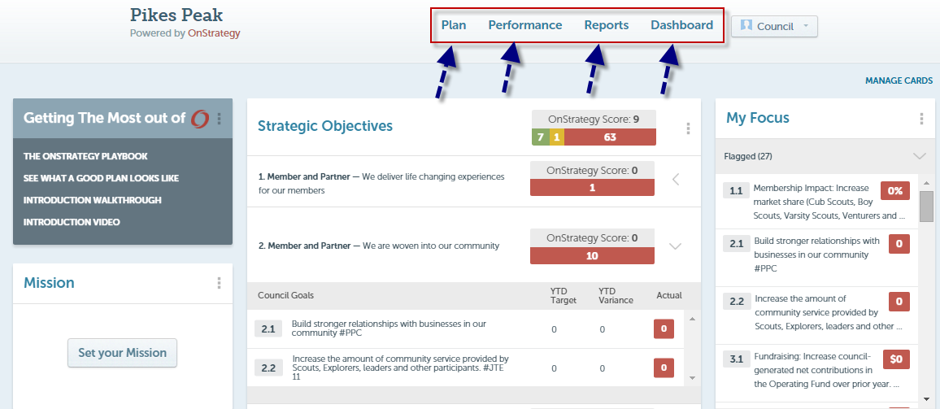

On the Performance Overview, you can see at a glance the status of goals:
- Red are Critical
- Yellow are Waiting on Someone or Off Target
- Blue are Not Started or Deferred
- Green are On Target or Achieved

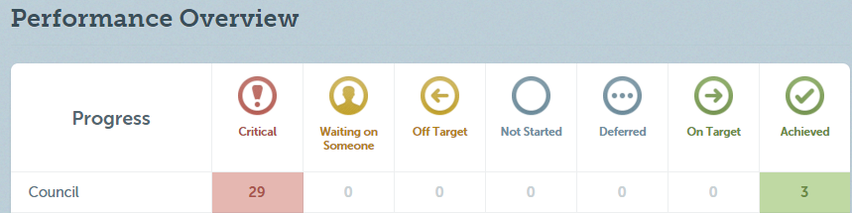
And if you want to dive deeper, you can look at any individual metric and understand its current status, whether or not it is on or off target, the dates within the performance you are tracking, and much more.

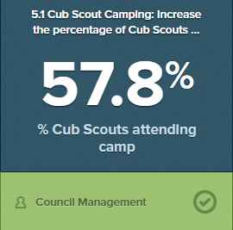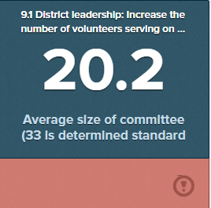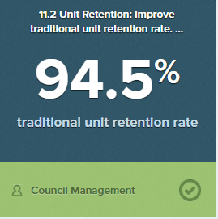

Ultimately, the effort of a strategy map, balanced scorecard, and all these online tools will help your local council team—volunteers, board, and staff—move forward in the same direction.

When you and your staff, board, and volunteers are ready to journey into strategic planning or embrace this online tool, just reach out to the BSA Strategy team. We can help you:

- Get your licenses for access to the online My Council Plan
- Input of your initial strategic plan online into the My Council Plan
- Train and coach to use these online tools in your strategic planning and execution
- Understand the BSA Strategy and how it impacts your Journey to Excellence success

For more info, contact the Strategy Team:

Tom Jansen, CPLP —Team Leader, Strategy
972-580-2542 thomas.jansen@scouting.org
Nesia Harris– Program Assistant, Strategy
972-580-2582 nesia.harris@scouting.org

