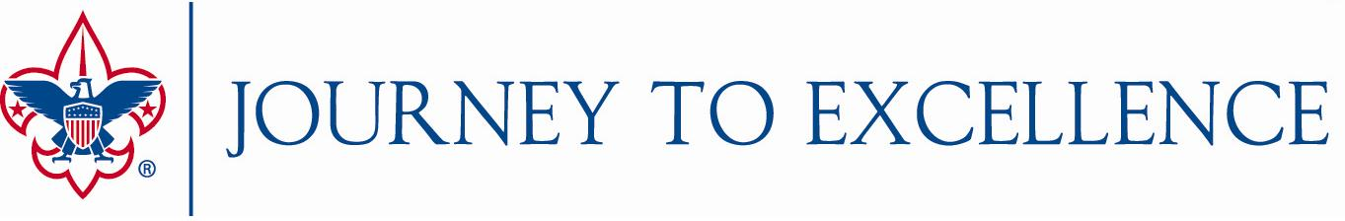
2018 Strategies for Future Growth
Journey to Excellence Bonus Points for Councils
The BSA National Key 3 offers councils opportunities to earn bonus points in these areas that contribute to the future growth of Scouting (up to a maximum of 100 total points):
- Duty to God – Conduct a substantial council-wide activity dedicated to Duty to God during 2018. (25 points)
- New Member Coordinators – Have at least 25% of packs and troops with a registered new member coordinator by the end of 2018. (25 points)
- Learning for Life Growth Plan – A growth plan for Learning for Life curriculum-based programs has been developed and implemented in the council. (25 points)
- Board Diversity – Increase the diversity of registered council executive board members in 2018 compared to 2017. (25 points)
Points will not be added to a single Journey to Excellence criterion, but will be included in the 2018 final score when the dashboard is updated at the end of January 2019. A reporting tool will be available at the end of 2018, and councils will need to submit their results by January 20, 2019.

Journey to Excellence Bonus Points for Districts
The ___________ Council Key 3 offers our districts opportunities to earn bonus points in these areas that contribute to the future growth of Scouting (up to a maximum of 100 total points):
- ___________________________________________________________________
- ___________________________________________________________________
- ___________________________________________________________________
- ___________________________________________________________________
- ___________________________________________________________________

Councils may offer one or more opportunities for their districts to earn bonus points based upon their key strategies. As with council bonus points, these will be added to a district’s total score at the end of January 2019, and councils will need to submit their district results by January 20, 2019.

Council Bonus Items Explained …

Duty to God
The Duty to God activity should be a substantial council-wide or multi-district activity where Scouts and Scouters from multiple faiths are invited and involved. It may be organized and guided by a single faith, but other faiths should be included, which is strongly encouraged. Ideally, youth will be deeply involved. Examples might include: Council hike to ten houses of worship (Ten Commandments Hike), special council breakfast or dinner, council day of service, council interfaith symposium, or a council chartered organization representative membership drive. A routine activity, such as a court of honor held by a single faith to present religious emblems, would not qualify. For more information, please check out: http://www.facebook.com/dutytogodbsa.
New Member Coordinators
New Member Coordinator (NMC) is a new unit level position for all units. The NMC’s job is to welcome new members and parents, make them feel comfortable in the unit and encourage and support their initial participation in the activities of the unit. The principal function of the NMC is to encourage involvement and retention by new members and their families. Multiple NMCs in a unit can use a team approach to share the benefits of Scouting, coordinate unit recruitment, and guide joining and engagement processes. More information and training for NMCs is available at: http://scoutingwire.org/marketing-and-membership-hub/councils/new-member-coordinator/.
Learning for Life Growth Plan
During the council staff planning conference include the Learning for Life curriculum-based program as part of the overall council membership plan. Within the growth plan, there should be specific goals and objectives with a specific measurement piece to achieve growth.
Board Diversity
We want to be reflective of the diversity of the communities we serve. The council has developed a written plan to improve the diversity of registered and engaged council executive board members who share the council’s vision and interest in accomplishing the mission of Scouting. The plan was issued as a charge for the nominating committee.

