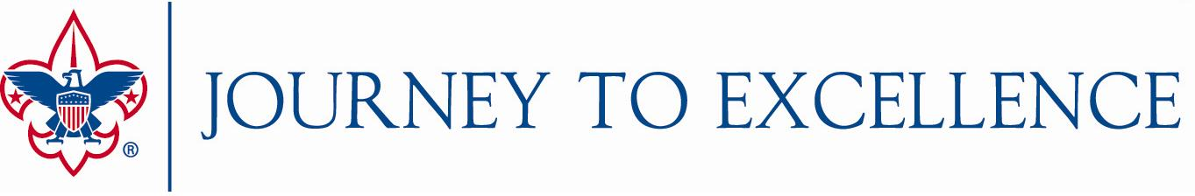
2017 Strategies for Future Growth

Journey to Excellence Bonus Points for Councils
The BSA National Key 3 offers councils opportunities to earn bonus points in these areas that contribute to the future growth of Scouting. (up to a maximum of 100 total points):
- Cub Scout Den Leadership – Maintain a ratio of 8 Cub Scouts or fewer per registered den leader or reduce the ratio by at least one Cub Scout per leader. (50 points)
- National Jamboree Attendance – Achieve 2017 National Jamboree attendance goals. (25 points)
- Venturing Officers’ Association - Maintain an active Venturing Officers’ Association with youth leadership in place (and volunteer advisor and staff advisor) that meets at least four times during 2017. (25 points)
- Council Exploring Committee - Maintain an active Exploring committee of at least 5 members that meets at least four times during 2017. (25 points)
- Board Diversity – Increase the diversity of registered council executive board members in 2017 compared to 2016 (25 points)
Points will not be added to a single Journey to Excellence criterion, but will be included in the 2017 final score when the dashboard is updated at the end of January 2018. A reporting tool will be available at the end of 2017, and councils will need to submit their results by January 20, 2018.

Journey to Excellence Bonus Points for Districts
The ___________ Council Key 3 offers our districts opportunities to earn bonus points in these areas that contribute to the future growth of Scouting. (up to a maximum of 100 total points):
- ___________________________________________________________________
- ___________________________________________________________________
- ___________________________________________________________________
- ___________________________________________________________________
- ___________________________________________________________________

Councils may offer one or more opportunities for their districts to earn bonus points based upon their key strategies. As with council bonus points, these will be added to a district’s total score at the end of January 2018, and councils will need to submit their district results by January 20, 2018.

