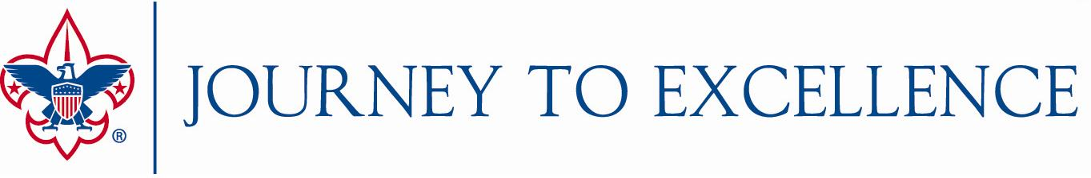
2016 Strategies for Future Growth

Journey to Excellence Bonus Points for Councils
The BSA National Key 3 offers councils opportunities to earn bonus points in these areas that contribute to the future growth of Scouting. (up to a maximum of 100 total points):
- Cub Scout Recruitment - Register more new Cub Scouts in 2016 compared to 2015. (50 points)
- Exploring Membership - Achieve growth in Exploring membership on December 31, 2016 as compared to December 31, 2015. (25 points)
- Board Diversity – Increase the diversity of registered council executive board members in 2016 compared to 2015 (25 points)
- Venturing Officers’ Association - Maintain an active Venturing Officers’ Association with youth leadership in place (and volunteer advisor and staff advisor) that meets at least four times during 2016. (25 points)
Points will not be added to a single Journey to Excellence criterion, but will be included in the 2016 final score when the dashboard is updated at the end of January 2017. A reporting tool will be available at the end of 2016, and councils will need to submit their results by January 20, 2017.

Journey to Excellence Bonus Points for Districts
The ___________ Council Key 3 offers our districts opportunities to earn bonus points in these areas that contribute to the future growth of Scouting. (up to a maximum of 100 total points):
- ___________________________________________________________________
- ___________________________________________________________________
- ___________________________________________________________________
- ___________________________________________________________________
- ___________________________________________________________________

Councils may offer one or more opportunities for their districts to earn bonus points based upon their key strategies. As with council bonus points, these will be added to a district’s total score at the end of January 2017, and councils will need to submit their district results by January 20, 2017.

