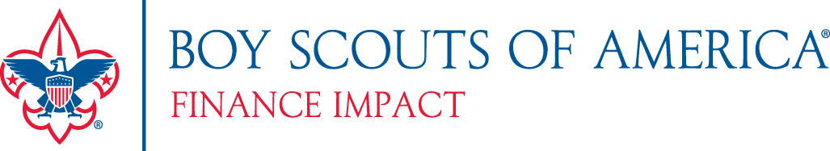
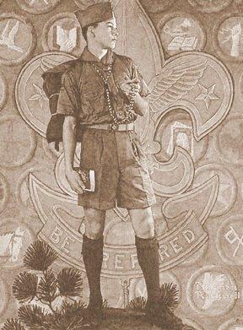
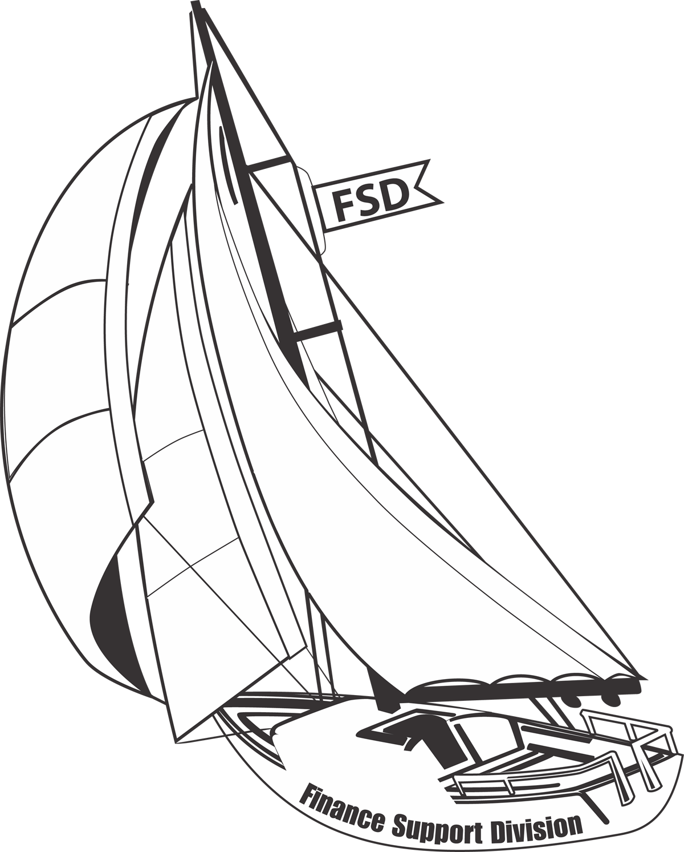

HOW-TO-GUIDE

RESEARCHING FOUNDATIONS
AND WRITING GRANT PROPOSALS

FOREWORD

CHAPTER ONE: INTRODUCTION

History of Foundations 4
Types of Foundations 4
State and Federal Funding 5
Building a Volunteer Council Foundation Committee 9

CHAPTER TWO: RESEARCHING FOUNDATIONS

The First Step 10
What is Research (Data Mining)? 10
Top 10 Ways to Get Started 11
How to Sharpen Your Foundation Research Skills 15
Marketing Language for Your Proposals 16
Fundamentals of Corporate Giving 16
How to Cultivate and Maintain Relationships With
Prospective Corporations/Foundations 18
The Foundation Center Resource for Finding Grants 19
Summary 19

CHAPTER THREE: PLANNING AND PROPOSAL WRITING

Basic Principles of Proposal Writing 20
The Proposal 22
Types of Proposals: Inquiry, Formal, Online 22
The 10 Components of the Proposal Format 23
Submitting and Resubmitting the Proposal 28
Checklist for Proposal Writing 29
What Some Foundation Directors Say 31
Words From the Experts 35
Summary 35

APPENDICES

Appendix A: Proposal Writing Is a Revolving Process
Appendix B: Online Resources for Local, State and Federal Grants
Appendix C: (Sample) Foundations Tracking Timeline Chart
Appendix D1-D2: (Sample) Outcomes Measurement Logic Model Template
Appendix E1-E2: (Sample) Outcomes Survey/Evaluation
Appendix F: (Sample) Letter of Inquiry/Cover Letter
Appendix G: (Sample) Executive Summary
Appendix H: (Sample) Budget

FOREWORD

Philanthropic giving in the United States is one of America's largest industries, totaling
several hundred billion dollars in giving, with a large percentage by individuals – combined as outright gifts or through bequests.

Individuals lead the way with over 85 percent of all charitable contributions. Gifts from foundations represent less than 10 percent of all charitable giving, and corporate gifts account for less than 5 percent of this total.

As our Scouting programs grow, so does the need for funds to support council budgets and
capital campaigns. But the competition for these charitable dollars is also growing. This
competition has caused local councils to look at less "traditional" sources of revenue to meet
their financial needs. The majority of gifts come from individuals, so the majority of your time
and effort in raising funds should focus on them. However, foundation support and corporate giving programs are potentially valuable funding sources that councils should explore for potential new income.

Although foundations and corporations contribute less than 20 percent of the total charitable dollars in the United States, local councils receive less than 5 percent of their revenues from these sources.

The How-to Guide for Researching Foundations and Writing Grant Proposals will
help councils get started in the field of grant writing, and will also provide resources and ideas for councils looking to expand their current foundation efforts. Whether you’re a novice or a seasoned pro, there’s something here for you.

This guide will help councils get a better understanding of the various types of foundations, how they operate, how they should be contacted, and where they are located. Next, the focus is on how to conduct research and "match" your project with the interests of a foundation. Once you have a match, plan the contents of the proposal, establish the proper proposal format, and focus on how to put your thoughts into writing.

As with most projects, the most difficult part of grant writing is getting those first few words on paper. To help you start, check out some sample pre-written generic templates and sample proposals that are available at the FID Web site. (www.scouting.org/financeimpact)

There are also many other directories, books, and Internet resources that can be extremely
useful in your grant writing program. State, regional, and national foundation directories are
available at your local library – or, for a minimal purchase online or from the Foundation Center at www.fdncenter.org. (These resources are discussed later in this manual).

The Grantsmanship Center is also an excellent resource and has a number of sample proposals (www.tgci.com).

Best of luck as you enter or move more deeply into this challenging but rewarding source
for funding Scouting’s future.

CHAPTER ONE

INTRODUCTION

History of Foundations

The modern foundation of today is a descendant of those established by the early Roman
Empire. Those foundations were born more out of pragmatism than philanthropy (they were
used for social control, providing resources to the poor to keep them from rioting). Despite its
dubious origins, this was the beginning of a shift from private support to public charitable
associations. Even the Greeks are believed to have been strong advocates of foundation giving. Aristotle, in The Nicomachean Ethics, said, “It is easy to give and spend money, but to decide to whom to give it, and how much and when, and for what purpose and how … this is not easy.”

The concept of a foundation was legally defined as early as 1601 in the "English Statute of
Charitable Uses." This statute allowed the state to grant certain privileges to private citizens in exchange for their willingness to serve the public good by supporting or performing acts of
charity. The language of this almost 400-year-old statute is still remarkably accurate in its
definition of charitable giving.

The general purpose foundation, whose charter enables its trustees to address problems affecting the general welfare, is an American innovation originating in the late 19th and early 20th centuries, prior to World War I. Two of the most notable examples are the Carnegie
Corporation of New York (founded in 1911) and the Rockefeller Foundation (founded in 1913).
Today's modern foundation is a nongovernmental, nonprofit organization with funds and
programs managed by its own directors or trustees. This organization maintains social,
educational, charitable, religious, or other activities serving the common welfare primarily
through the making of grants.

Types of Foundations

1. Independent/Private/Family Foundation: relatively small and usually with no staff or staffed with family members. They limit their grants to specific areas of local interest. The assets of these foundations are generally derived from the gift of an individual or family.
Although the size of gifts that councils receive from this source may be smaller, there are more family foundations than any other type and they are a good source of potential council support. In many cases, no formal proposal is needed with a family foundation. These foundations can also be strong prospects for major gifts to your council's Friends of Scouting campaigns.

A. Local Banks can also be a great resource for funding through family foundations and private trusts. Try to identify the trustee(s) who handle these funds and make an appointment with them. Take along with you influential council/district volunteer(s) to meet him/her together. Discuss Scouting’s positive impact on the community.

2. Corporate or Company-Sponsored Foundations: the charitable giving arm of a corporation, often funded with assets or income of that corporation. Officers of the company, as well as persons not connected with the business, may serve on the board. Grants are usually made to organizations in the communities in which the company carries on its business activity.
Often, funding requests can be initiated through a branch, regional office, or subsidiary of the parent company (though decisions are often made by the corporate headquarters). These are particularly good sources for council funds if the company has its headquarters or a regional office or division in the council service area.

3. Community Foundations: broad-based, increasingly popular, and growing rapidly. These foundations usually have a governing board that is highly representative of the community it serves. Grants are usually limited to that community, and the foundation assets come from many donors with many varied interests. Community foundations can provide local council support through field-of-interest funds, undesignated assets for projects of interest to the foundation, or special-purpose funds created by individual donors.

A. Service clubs, fraternal, and civic organizations have local foundations within their organizational structures that will allow requests for funding from youth organizations. Make sure to visit them. Get to know their board and members. It is especially important to volunteer to speak at one or more of their chapter meetings and programs. Provide them with a presentation update on the impact Scouting is making in the 21st century in their community. Also, talk to them about the impact local Eagle Scouts have made in their community, and share with them the economic impact value of council and national service projects.

4. General Purpose and National Foundations: fund broad purposes and priorities set by a board of trustees in response to social change and need. Some of the largest foundations –
Ford, Rockefeller, Kellogg – are included in this group. These foundations hold the majority of the total foundation assets. Large foundations often support only large grant requests or proposals from a national organization, rather than a local council or chapter.

However, local council programs may be supported if the council happens to be located in the same city as the foundation, and the foundation has a special pool of “local” money.

State and Federal Funding

In order to apply for federal funding, an organization must have a DUNS number.
The Data Universal Numbering System (DUNS) number is a unique nine-digit identification number provided by Dun & Bradstreet (D&B). Call 1-800-333-0505 for a DUNS number.

Types of Federal Assistance

Federally Administered Programs:
Applicant submits grant proposal to a federal agency.

State and Locally Administered Programs:
Applicant submits grant proposal to a state or local agency.

Other Programs:
Funding opportunities that are not traditional grant programs

Researching Grant Programs

CFDA.gov: The online Catalog of Federal Domestic Assistance, which lists all of the funding opportunities available to the public (Note: each program has its own identification number.)

Grants.gov: A single access point for over 1,000 grant programs offered by 26 federal grant-making agencies, as well as some state and local governments

Grant Application Notice

. Published in the Federal Register
. Accessible via the Web
. Contains all vital information
. Selection criteria
. Competitive priorities
. Contact info for program office
. Deadline

Getting Started

. Identify and prioritize community needs and problems
. Assess your organization’s talents and strengths
. What do you do well?
. What do you want to accomplish?
. What are the short-term and long-term goals for meeting community needs?
. With whom can you partner?
. Don’t take on more than you can handle.

Key Questions

. Who is eligible?
. What is the deadline?
. What is the award amount per grant?
. How many projects will be funded?
. Who is the program contact?
. Is there a matching requirement?
. Where can I get the application?
. Is there a page limit?
. How and where do I submit the application?

Need for Project

. Explain how community need ties into the grant program’s purpose.
. Use most recent statistics.
. Utilize Census.gov (American Fact-finder).
. Local government data
. Compare target area to region and nation.
. Demonstrate through facts.
. Avoid jargon and rhetoric.

Project Personnel

. Provide detailed job descriptions.
. Paid staff
. Volunteers
. Highlight qualifications of proposed staff.
. Include resumes (if applicable).
. Demonstrate staff’s ability to relate to target population.
. Address staff’s professional development.
. Align salaries with time and effort.

Project Evaluation

. Measure goals and objectives.
. Are they ambitious and attainable?
. What indicators will demonstrate progress?
. Are they achieved through services?
. Review project performance monthly or quarterly.
. Does it meet the need outlined in the proposal?
. Is it a tool for replicating success?
. Include staff input and participant feedback.

Budget

. Budget for the life of the grant.
. Allowable costs
. Indirect Cost Rate Agreement
. Cost-of-living increases
. Address matching requirements.
. Seek non-federal support.
. Focus on sustainability.

Completing the Application

. SF (Standard Form) 424 “face page”
. SF (Standard Form) 524 budget form
. Budget narrative
. Certifications and assurances
. One-page abstract (summary)
. Application narrative
. Appendix

Submitting the Application

. See application notice for submission details.
. Grants.gov
. Agency-specific Web portal
. Hard copy in the mail
. Be aware of registration procedures and complete early.
. Allow time for application to be submitted.

Processing the Application

. Received by the awarding agency
. Given a unique ID number
. Screened for eligibility
. Reviewed by a panel of experts
. Scored and ranked with a point system
. Recommended for funding

ALL Valuable Resources

. Technical assistance
. Workshops
. Webcasts
. Conference calls
. Sample grant proposals
. Research studies
. Successful grantees

Web site resource:

http://www.grants.gov/

Sample available federal/state grants for nonprofit youth organizations.

“Leave No Child Behind” after-school program funding grants are available from the federal government for schools with 40 percent of underprivileged economically disadvantaged youth. Local council Scoutreach programs could perhaps benefit from this type of funding.

“Workforce Development” state and federal grants are available in partnership with chambers of commerce, local workforce development youth boards, and community colleges. Local councils should contact them to determine ways to fund their in-school programs for high school-age youth.

Building a Volunteer Council Foundation Committee

The Foundation Committee

A local council may find it useful to form a small committee to help with the many steps involved in putting together a strong foundation proposal. The committee should be small – three to five persons – but with a strong knowledge of the council and its needs as well as the community and top community leadership.

Good prospects for the committee will include current or past directors and trustees for other foundations (though committee members currently serving on the board of a potential funding source may face some conflict-of-interest issues). Those involved with major campaigns and advancement work for other organizations are also good prospects, such as university or college development directors, directors of hospital or social agencies, or past corporate
executives and directors.

Committee responsibilities may include the following:

• Join an ongoing permanent subcommittee of the council finance committee; meet monthly, or as often as needed, to complete assignments.

• Identify, research, and compile a list of foundation prospects that match up with the grant amounts, projects, and needs of the council.

• Screen and refine the list to come up with a “Top 10” prospect list, and create a timetable for each to make sure that proposals don’t miss foundation deadlines.

• Determine the best approach for each funding prospect, including finding the best personal contacts with each foundation, if any.

• Help prepare a proposal, cover letter, and support documents for each of the “Top 10” prospects.

• Review, critique, and refine all proposals, making sure the grant requests are clear and accurate, state a compelling need and reason for funding, and do a good job telling the “Scouting story” and the difference it makes in the community.

• Assist in making personal calls and establishing contacts with foundations, and help follow up each proposal.

• Be ready to provide further information as needed, or answer questions about the project or programs you are asking them to support.

Committee members need to work closely with the Scout executive or other assigned professional staff member to ensure the accuracy of the foundation proposal. Adequate preparation by a small but dedicated volunteer committee will pay great dividends. Obviously,
not every foundation contact and proposal will result in a grant. But the council's success rate (and your skill as a grant writer) will improve with each proposal and your courteous and professional follow-up with potential grantors.

CHAPTER TWO
RESEARCHING FOUNDATIONS

The First Step

Research – not writing – is the first step in securing a foundation grant. You’d no sooner start a proposal without research than start writing a great novel without a plot or characters. You’ll likely discover that approximately 80 percent of the time spent with a proposal will be spent in research.

Before you can create a persuasive and effective proposal, you must do your homework. Understand your council's long-range objectives by reviewing the council’s strategic plan, the background and current funding interests of the prospective grantor, and the details of your particular project. These will largely determine the content and format of your proposal.

The most important aspect of a successful proposal? Match your council's needs with the goals and interests of your potential grantor. If they match, then begin developing an emotionally compelling case statement and need for support. Explain why you truly need their funding and how it will change the lives of youth in a positive way.

If they don’t match up, don’t waste any more time with that prospect. Just move on to another. It doesn’t matter how urgent your need, how impressive your prose or statistics, or how influential your council president or board members are. You will not succeed unless your project is one that the foundation can (or wants) to fund.
Learn everything you can about the foundation: its history, goals, philosophy, board members, and its program officers who will read and respond to your proposal.

What Is Research (Data Mining)?

Research used to be sitting in the library for hours paging through national foundation and corporate directories. And some still prefer to do it this way. However, thanks to technology, research or “data mining” (foundation language), has become faster, less complicated, and more time productive, thanks to the Internet. In particular, with the use of online resources, you can now access valuable information from your computer at work, at home, and even in some community and neighborhood libraries.

Research involves:

- Collecting information about other youth organization programs, foundations,
corporations, and industry leaders in your community.
- Organizing your information so you can easily access it and refer to it.
- Talking with your board members, service club members, and local community leaders about issues and other charitable initiatives and campaigns in your area.
- Reading newspapers, magazines, annual reports, business journals and publications.
- Reviewing the state and national foundation and corporate giving directories (as well as the many other publications suggested in the back of this manual).
- Analyzing press releases, annual reports, and giving patterns of potential grantors.
- Discussing strategy and investigating personal contacts with foundations with your council president, foundation committee, and other council volunteers.

Checklist for Researching the Foundation in a Directory or Online:

- Match a BSA need with a foundation’s need.
- Who will be our proposal champion?
- Which foundation should be contacted?
- How much money should we request?
- What types of funding should we request?
- Operating, capital, endowment, matching, new seed money, project sales, gift in kind?
- How long should the fund be? One, three, five years?
- What is the foundation’s time frame for receiving requests?
- Finding a champion

Top 10 Ways to Get Started

1. Create and organize subject files. Create files – either hard copies or computer files – of
the important information you read and gather, whether or not it relates to a specific project or seems to have any immediate use. As the Chinese proverb goes, “the palest ink reveals more than the clearest memory,” so it is crucial to organize the information you compile. One excellent way to do it is to set up "subject files." Here, you can collect all online information, newspaper articles, names, notes, and information about other programs that receive financial support from grantors in your community.
Some suggested subject files include:

Sample Community Needs/Concerns Files

- Disabilities
- Crime
- Drugs
- Child Abuse
- Environment Careers
- Unemployment
- School Dropouts
- Homelessness
- Diversity
- Ethics
- Demographics
- Illiteracy
- Hunger
- Elderly
- Health

Sample BSA Community Problem-Solving Files

- Strengthening families
- Overcoming obesity
- Safe environment
- Protecting the outdoor environment
- Meeting basic needs
- Personal well-being and independence
- Nurture children and youth for success
- Prepared workforce/education
- Good Turn for America: Combating lack of shelter, poverty, homelessness
- Scouting for Food
- Local council Eagle Scout community service projects

2. Review council files. Who has supported the council in the past, what did they fund, or
why did they refuse to fund it? There may be a gold mine of information tucked away in your own files about grantors that could be approached for a gift to Scouting. If a foundation gave to the council once before, they may give once again. If they didn't give the first time, maybe they had already committed their funds to other programs that year, or were asked to support the wrong program. For example, they may have turned you down on a capital request for a camp dining hall, but would have rather had a Scoutreach proposal.

3. Go through foundation and corporate giving directories. Determine which
foundations give to youth organizations in your area and support the types of projects for which you are seeking funds. If the foundation has made grants to others, but for projects similar to yours, you’re definitely on the right track.

Focus on state/county directories and information for foundations located in your community
(a sample listing of state directories is in the back of this manual). These directories are very
comprehensive and often include even the smallest foundations in the community.
Another great source is the Foundation Directory. Its listings will not include many small
foundations, but all of the largest foundations and corporate giving programs are in it, and it is the most up-to-date resource anywhere. It can be accessed through the Research Portal on the FID Web site. (Detailed directions for accessing can be found at the end of this chapter.) Foundation directories usually provide the following information for each foundation:

- Name, address, and phone number of the foundation.
- Name of contact person – The person to whom your proposal should be sent and
your cover letter addressed. Do not send it to anyone else, unless you have been
instructed to do so by the foundation. Call to confirm the name before you send
your proposal.
- Amount of assets – This is especially important to note when you are using state
directories that list all foundations, regardless of size.
- Amount of contributions received – The names of those contributors can be found in
the IRS Form 990 for the foundation (see next section).
- Amount of typical grant range – Important to help determine the size of your grant
request.
- Areas of interest – Helps you match up grantor interests with your project. Many
times, it also lists the kinds of projects the foundation won't fund, and would
immediately rule out the foundation as a prospect.
- Geographical restrictions in giving – This should be some of the first information
you check. If the grantor isn’t located in your community, or if they don't support
projects in your area, don’t waste your time doing a proposal.
- Names of officers and trustees – Check for board members who are also on the
council’s board, who are friends of Scouting, etc. Their colleges and other interests are often listed, and you may find additional connections through this. The stronger your personal connection with the foundation, the greater the chance that your proposal will get the attention it deserves.
- Type of foundation and a short history – A good overview of the foundation's
philosophy and background.
- Sample list of recent grants with recipient and amount – The types of organizations
they support, and the size of grants that others get, are vital pieces of the puzzle.
- Instructions for making an initial contact – This tells you what they expect from you,
and when they expect it. They may want you to submit a two-page summary of your project, a cover letter, a full-length proposal, or an online application. But it is critical that you find this out.
- You may want to call the person listed as the foundation's contact person, give them a brief overview of your project, and ask if your project is one they’d consider funding. If it is, they may offer some excellent suggestions for your project. If it isn’t the kind of project they support, you’ve saved yourself and a lot of other people a lot of work.

4. Foundation Form 990s. IRS Form 990s can be an excellent source of information.
Virtually all foundations file an annual 990 report with the IRS and the attorney general or secretary of state where the foundation is located. In general, there are 10 categories of information that a 990 will provide:

- The address of the foundation's principal office, and its books and records
- Total contributions and gifts received during the year
- Gross income for the year
- Annual disbursements (including administrative expenses)
- Expenses attributable to gross income incurred within the year (broker's fees, bank
or trust charges, property management, etc.)
- The names and addresses of its managers, and the salaries of its top officers
- A list of managers who are also substantial contributors or own 10 percent of a
business enterprise in which the foundation has a 10 percent interest
- A balance sheet showing assets, liabilities, and net worth
- An itemized account of all securities and other assets, including both book and
market value
- All grants made or approved during the year, the name and address of each
recipient, the amount and purpose of the grant, and the relationship, if any, between
any recipient and the foundation's managers or substantial contributors

How do you gain access to a Form 990 for a foundation?

First, start online. Most recent 990s can be found online at www.guidestar.org. You’ll likely find a lot of other relevant information here as well.

Second, you can call, write or e-mail the foundation itself and ask them for a copy of their recent 990. They must provide it under the Freedom of Information Act. This requires you to either go to the foundation offices or wait for them to mail it (which may, of course, be impractical or inefficient).

Third, you may request it from the IRS or the appropriate state regulatory office. You’ll need to identify the foundation by its tax ID number (found in the foundation directories or online at www.guidestar.org). If you order from the state or the IRS, they can be extremely slow – this isn’t a high priority for them – and there may be copying charges and handling fees.

5. Visit your library and review their collection of foundation information. This is an
especially good place to look for the state/county foundation directories.

6. Start your own BSA research library. If you plan to write and submit many grant proposals over the next few years, you may want to buy a copy of your state's foundation directory and subscribe to updates. This may be worth it if it’s difficult for you to get this information any other way.

National BSA Research Service is another great library resource. They have data such as 1995 Louis Harris Interactive study results reported in The Values of Men and Boys in America; One Year in the Life of a Cub Scout, Boy Scout, and Venturer; Summer Camp Outcomes Study; and Volunteers Outcome Study, 40 assets of successful Youth from the Search Institute.

7. Make prospect lists. Rate your top prospects in order of potential – top prospects
should be top priorities.

8. Research the key foundation contacts. These are the people responsible for receiving,
reviewing, and deciding which proposals should be presented to the foundation directors or trustees for final approval or rejection. The top person is usually the executive director, but a program officer, grants administrator, or designated vice president will usually be the place to start with your grant proposals.

9. Use online computer research capabilities. An enormous world of information is
available on the Internet. Through research portals and search engines such as Google, Yahoo, and others, research of individuals and foundations is easier and more
accurate than ever. The Finance Impact Department Web site (www.scouting.org/financeimpact) is an excellent place to start.

10. Make a personal contact with the foundation. The best approach is to meet with the person who will receive your proposal. "Put a face" on your proposal. Explain the project in person, and ask what they want to see in the proposal. Lack of personal contact is often fatal to the success of your proposal. Many foundations "weed out" and quickly dispose of proposals where there is no personal contact. It is much easier to say no to someone you don’t know.

Studies show that without personal contact between a foundation and a charity, a proposal has about a 5 percent success rate. But once personal contact is established, the success rate rises to about 20 percent. Then, continue to maintain positive relationships. And more important, begin to build new ones as well.
How to Sharpen Your Foundation Research Skills

There are several things to remember when doing foundation research:

1. Many foundations make grants in certain geographic areas only, usually where they
are located. For example, if you were the Scout executive of (XYZ council), your best foundations will be (in order of priority):

a) In the county, city, or town in which the council resides
b) In the state where the council resides
c) Out-of-state, but still fund projects listed in your state
d) Those that give nationally

Many times, the initiatives and interests of a foundation often reflect the interests of its current board members or staff – regardless of stated grant limitations. This is why personal contacts with foundation staff or board members or the executive director can be particularly useful.

2. Foundations have their own priorities and interests that determine the type of
programs they support. Normally, your research will help you identify the foundations that are
interested in supporting youth.

3. Foundations may prefer to support specific organizations within the listed types.
Even with those foundations that support youth activities, you may find they support other youth organizations but don’t list Scouting. Again, this tends to reflect the interests of current board members and may change periodically.

4. Most foundations have certain segments of the population that they want to be
served by any programs they support through their grants. For example, foundations that
support youth organizations are obviously good prospects. But you may also find strong
prospects among foundations that support low-income areas or communities with a large
Hispanic population. A match in these funding areas might interest a foundation in
funding your youth-at-risk program, drug awareness efforts, or Hispanic emphasis program, for example.

5. Foundations often make their money available for specific purposes. Sometimes
foundations are willing to give money to a council's operating budget. Some foundations will,
however, support building funds, equipment purchases, translation of program materials, and
many will provide seed money to get a new and innovative program started.

6. Make it easy to update your research, and don't assume your information is up to
date, or even accurate. Always cross-check and verify the most important bits of information
you will need. Even a brand new foundation directory is three to six months behind on information,
position changes, etc.

7. Use indexes for researching, such as Business Periodicals Index, Moody's Corporate
Index, Standard and Poor's Corporate Register, and Reader's Guide to Periodical Literature.

8. Don't over-research. No need to compile a foundation's giving history for the last 10
years if you really only need the last two years. Because of changing foundation personnel,
board members, and even philosophies, only the most recent information will be useful.

Marketing Language for Your Proposals

The Boy Scouts of America has its own terminology used for identifying various activities, recognitions, and programs. For example, words like roundtable, Silver Beaver, Order of the Arrow, Tiger Cubs, Webelos, Explorers, and Venturers may all have specific meaning to a person who is actively involved in Scouting programs.

And perhaps these meanings and acronyms even begin to make sense over a period of time to an individual outside of the Scouting program, but what about those who are not involved in or aware of Scouting? How do we communicate to them so we can write an RFP? (This is foundation language) = (Request for Funding Proposal)

The answer is simple. We must learn to speak the language of the funders. Like a mirror reflects back what it sees, so you must do when it comes to writing your proposals. “Use the language of the funders” to better communicate Scouting’s needs. Explain the methods of Scouting. Such as: A “Scout camp” is more than just a facility outside for hundreds of youth to play and have fun. It is an “educational outdoor environmental center” which positively impacts youth as they learn life skills such as mentoring, leadership, conflict resolution, confidence, self-esteem…and much more.

Fundamentals of Corporate Giving

Most of the fundamentals of proposal writing and grant research are the same for both foundations and corporations. There are, however, a few differences.

Foundations exist primarily to give money away. Corporations exist primarily to make money
for their shareholders. There is something inherently suspicious about corporations giving
away money – after all, most shareholders are much more impressed with the size of their stock dividends than the philanthropic agenda of a corporation.

Corporations normally make charitable gifts and grants because they feel it is good business.
They reason that if people see the XYZ Corporation as a good citizen of the community because it supports worthwhile programs and local organizations, people may be more inclined to buy more of their products. It’s hard to have a healthy business in an unhealthy community.

Corporations often give according to the personal interests of their board and executives,
especially the president or CEO. They tend to give to organizations that serve, or are
philosophically aligned, with the demographic groups the corporation hopes to sell its products
to – its target market. This potentially is a two-edged sword, though, since corporations have
so many constituencies and customers that must “approve” of its philanthropic agenda.
An increasing number of corporations are instituting employee charitable incentive programs,
or turning all of their corporate grant-making over to the employees, either by popular vote or
representational vote (such as by an employee grant committee). This, again, may pose
challenges for councils in some areas. While empowering for the employees, it may be
frustrating for the council that has strong ties with a top management that has little or no say
over the corporation’s giving.

Fundamentals of Corporate Giving (Continued)

Because many local corporations may be regular donors to your council annual giving
campaign, it is extremely important to focus your efforts on local corporations. The closer you
are to a corporation, the closer you are to a gift. You should rank your corporate prospects in
this order:

- Established friends of the council, with personal contacts
- Past council donors, but no other relationship
- Corporations that have not given to the council before
- Nearby corporations that need further research
- Corporations you know won't support the council
- Identify corporations with business products and services that could be useful to the council. In some cases, the right gifts-in-kind may be almost as helpful to a council as gifts of cash.

Many corporations are now using intermediary entities for such gifts, such as www.giftsinkind.org. Councils directly contact these intermediaries for lists of available property for “grant” requests for the property.

Be observant to giving patterns and business trends within certain industries. For example,
don't waste your time on a proposal for a corporation that just posted its third straight quarter of record losses, or is in an industry showing a steady decline in demand and sales.

Outline in your proposal ways that the council can help the corporation in return for the gift.
This involves good publicity, improved community relations, and even the idea that the
Scouting program will develop future employees for the corporation that are of particularly
strong moral character and reliable. Just be aware of corporations that stand to benefit more
from their association with your council than your council will benefit.

Find out if a corporation gives directly from the corporation, or from a corporate foundation – they are often completely different and distinct organizations. Also find out if the corporate
gifts come out of the national headquarters, or whether each region or factory has separate
giving programs and guidelines. You will find this information in most research tools, or by
simply calling the corporation directly.

The "Favor Bank.” The idea of a favor bank is one that the Harvard Business Review has found to be one of the most effective mergers of charitable giving and corporate contacts. For
example, Company A makes a grant to your council. By doing so it hopes to receive or "bank"
favors from your council in four ways: 1) Company A hopes the council buys or uses its
products or services; 2) from Company B, who already has a strong relationship with the
council and might do business with Company A as a fellow “friend of Scouting”; 3) from other
community leaders/politicians that already support the council and may look favorably upon
Company A's support; and 4) hoping the council will provide expertise or “intellectual capital”
of their executive board members that Company A could use.

Obviously, strong local council contacts will make the idea of a "favor bank" even more
attractive to a corporation. However, these contacts also make it even easier for a corporation to justify supporting your council, if the favor bank helps advance the corporation’s own internal agenda.

How to Cultivate and Maintain Relationships With Prospective Corporations/Foundations

- Besides asking for a grant, also look for assets or resources other than cash that a company could provide – including relationships, bulk purchasing power, access to market niche, or products and services. A foundation may fund your project for a few years, but through proper cultivation and meeting with key personnel face to face on a regular basis, you could possibly maintain funding even longer.

- Know the ownership structure, decision-making processes, and likely future operating strategies of a corporate/foundation prospect. Learn these through the business press, good prospect research, and conversations with corporate/foundation officers and other allies who know them. Do research by going online and checking out their Web site. Look at their annual reports online also.

- Identify where the company’s customers and your nonprofit’s mission, service(s), or customers overlap. How does your project fit in with the corporation/foundation’s mission? Include as part of your case statement for support the benefits for the company in a partnership with your nonprofit. Is there a proposal champion in your organization you can identify that can further your cause with the corporation/foundation as well?

- Cultivate and solicit corporate/foundation decision makers as for any major gift. Allow time for the prospective donor to get to know your organization and its good works. Send them updates and important information about your organization so they may become acquainted with the mission and services you provide before you receive funding, and especially after your request for funding has been granted.

- Even though we live in a high-speed, electronic, technically advanced society with computers, basic principles still apply to funding in corporations/foundations. Bottom line…it’s still a people business. People support other people and causes they believe in. Educate them on what your organization does to change and impact the lives of youth. E-mails are OK at times, but don’t simply hide behind computerized communication all the time. Go out and meet the funders. Set appointments. Get to know them. And perhaps they will reward your organization with the funding your valuable projects require.

The Foundation Center Resource for Finding Grants

The Fiscal Impact Department offers easy access to the Foundation Center Online Directory. It is a fast way to search for grants and foundations. To access it, follow these instructions.

NOTE: If your computer does not currently have Adobe Acrobat Reader installed, it’s a good idea to install it first. It is free online by accessing www.adobe.com.
to the login pages.

Note: The Fiscal Impact Department has 12 users’ licenses for councils to access the Foundation Center Web site, so only 12 users can be on the site at the same time. If you cannot connect to or access their Web site, wait and try again. It should not take long to connect.

Summary

The primary purpose of your research is to determine the foundation’s interests, the best way to bring your project to the foundation's attention, and to understand how your project meets the goals of the foundation. Remember: it's easy to say "we need it," but it's just as easy for the foundation to say "So what?" Research is a critical first step. Only with good information can we proceed to write winning proposals.

CHAPTER THREE
PLANNING AND PROPOSAL WRITING

Basic Principles of Proposal Writing

An effective proposal should reflect thoughtful planning. It must try to address and meet the
needs of three groups: your council, the youth served by your council, and the foundation you
are soliciting.
Think about one of your favorite movies and its structure: a) it’s a good story, b) effectively
told, c) to a targeted audience, d) with a series of images. If any of these elements are ignored, it won't be a good movie. Similarly, the same four elements must be part of your proposal; if you’re missing one, it won’t be a good proposal.

The proposal should be neat, clean, and easy to read!
Check the proposal carefully to eliminate typographical errors. Send only one original copy of
the proposal unless the foundation asks you to send multiple copies. Make the proposal
user-friendly. Break up the copy into manageable, readable paragraphs. Print the proposal on a good laser printer and use a format and typeface that is easy to read.

Don't use extravagant or inappropriate proposal packaging. Expensive covers suggest that you waste money; unnecessary use of color printing may imply the same. An elaborate binding may make it hard to separate the pages for copying. If you employ an unusual format or writing style, you may draw more attention to the form of the proposal than its contents. The moral is: if you’re going to be creative, do it well.

Write your proposal in a language the foundation will understand!
Proposal writing is not an opportunity to demonstrate your mastery of a foreign language.
Terms and references such as "FOS," "TAY," "DE," and many other unique Scouting terms may be commonplace for you, but they will be a foreign language to the foundation. If you must use such terms, explain or define them. To test the clarity of your writing, share a draft of the proposal with friends or family members who are not familiar with Scouting jargon. See if they know what you’re talking about!

Make it as short (or as long) as the foundation wants.
The proper length of a proposal is the length that the foundation wants. If they want a two page proposal with a cover letter, this doesn't mean one page, and it doesn't mean eight pages.
You can determine this by consulting a foundation directory or calling the foundation to discuss their proposal guidelines. If the foundation doesn't specify the length, err on the side of brevity.
Foundations would rather read a well-written 10-page proposal than a poorly written two pages.
But they’d probably rather read a well-written two-page proposal that covers the same
information!

Be positive.
Discuss and emphasize the positive impact the council has on your community; share some
success stories to show how effective your programs really are. Get "fired up" to write your
proposals. Remember you’re trying to give the foundation an opportunity to support
something exciting and important. Don’t address or call attention to any mistakes or failures
your council may have had. Don’t apologize for past transgressions (hopefully, there aren't
any), and don’t beg. You are not writing your parents from college asking for more money.

Avoid unsupported assumptions.
Don't say "we believe" something, when you can provide facts, figures, and experts to
substantiate it. If you are going to use any charts, graphs, or tables, put them at the end of the proposal, and refer to them in the body of the proposal. Otherwise, they clutter up the main part of the proposal. There are two things you must be particularly careful to avoid:

(1) Don’t assume that the foundation knows what Scouting is or does, just because
“everyone knows us.” They may have heard of you, but it doesn’t mean they know “who you
are.” This is your chance to tell them about your council and your successes;

(2) Don’t just talk about the national scope or impact of a problem. You must also prove
that the problem is significant in your community, and make a case for how your council's
programs can make a difference in addressing the problem.

You should no longer expect to receive money just because you are the Boy Scouts of America.
In fact, this may sometimes make your job even more difficult. Even if our constitutional
challenges are not an issue, some foundations have denied proposal requests because they feel we are more capable of getting the money elsewhere compared to other organizations.
Scouting has strong executive boards, high community awareness, a large and loyal donor base, and more than 90 years of history. Other organizations do not enjoy such obvious advantages, and this sometimes works against us regardless of the funding request’s quality or worth.

Remember these helpful hints.
The Tulsa County superintendent of schools gives some help, with tongue in cheek, about
"How to Write Good!"

1. Avoid alliteration always.
2. Prepositions are not words to end sentences with.
3. Avoid clichés like the plague.
4. Employ the vernacular ad nauseam.
5. Eschew abbrev., etc.
6. Parenthetical remarks (however relevant) are unnecessary.
7. It is wrong to ever split an infinitive.
8. Contractions aren't acceptable.
9. As Emerson said, "I hate quotations. Tell me what you know."
10. Comparisons are as bad as clichés.
11. One should never generalize.
12. Don't be redundant; it is highly superfluous to use more words than necessary, and it tires readers long before they get to the next point, especially if you write long, meandering, run-on sentences.
13. Be specific, more or less.
14. Finally, chech for pselling erros and typeos.

The Proposal

As you can tell, writing an effective proposal will require meeting with your foundation
committee (or other volunteer group involving your council leadership), and a lot of individual
work. The group will help develop the ideas and focus for the proposal, but it is, inevitably, the primary responsibility of one writer.

When the committee is satisfied with the proposal, share a draft with others for suggestions and comments. Don’t let the criticism of others offend you. Your goal is to have the best, most effective proposal. The committee should review all of the criticisms and comments, discuss them, and have these changes incorporated into the proposal before it is sent. Never let the style or form of the proposal be more important than the proposal's content!

You are using the proposal to sell your council and its programs; as such, it should be
convincing, persuasive, and well organized. Most foundations require supporting material
such as a list of officers and board members, proof of tax-exempt status (under IRC Sec. 501
(c)(3)), and a recent financial statement or audit. Proof of your council's fiscal responsibility will be of great importance to foundations.

Plan each proposal like you would a campaign and prepare a calendar of your grants written and submitted. Identify the deadline for each foundation proposal and work backward from that date. Set your own deadlines to complete each step of the grant writing procedure. As you get better at your grant writing – and as you develop components of and attachments to your proposal common to most of your proposals – and will need less time for each proposal. In the early stages, though, plan on about a nine-week "campaign period" to take each proposal from research to delivery.

Also, add a week or two to your schedule that comes after the foundation due date, for you to
follow up the proposal with calls or inquiries to the foundation. (See Appendix A)

Types of Proposals: Inquiry, Formal, Online

There are several ways to submit a proposal to a prospective foundation. Normally, the Foundation will list its requirements and guidelines for a Request for Funding Proposal (RFP) by listing in a local community, state, or national foundation directory. Sometimes their requirements are listed online through the foundation’s Web site, or in the Foundation Center’s national database. The most important thing to do for the proposal writer is to read the foundation’s guidelines and follow them accordingly.

Some foundations as an initial approach request a cover letter or a one-page letter of inquiry, either faxed or mailed, along with an executive summary (a one-page description of the proposal). Another may request that a formal proposal be sent describing the details of the entire project along with a case for support, budget, and outcomes. Some even mention a telephone call as an inquiry is acceptable. Yet, more and more foundations are now requesting online applications, where the initial letter of inquiry or full proposal is completed and sent through the foundation’s Web site or as an e-mail attachment. Every now and then a few may simply state “applications not accepted” or in other words, the only way to apply is for the foundation to initiate an application by sending it to your organization. This is where a proposal champion or through positive relationships building can help, or simply by knowing people in their foundation as well. Once the foundation knows what and how your organization matches their funding priorities, they could generate an application in your behalf. Keep them informed on what Scouting is doing to help positively change lives in the community. It may generate a foundation to seek you out and support your programs.

The 10 Components of the Proposal Format

Though the trend is toward common foundation applications, application forms, and shorter,
less elaborate proposals (especially among family foundations), some foundations still require a “full length” proposal containing many parts. A full proposal will normally contain 10
separate and unique parts. You may discover during your research (if you're lucky) that the
foundation only wants an "executive summary," or a simplified version of your proposal that
consists of only five or six of these components.

Of course, after the foundation reviews your shortened version, they may ask for additional
information, or a more elaborate version of what you sent. Remember: do not use these 10
components if a foundation has specified the use of a different proposal format. They will be
much more impressed with your ability and willingness to follow their rules and directions
than proving you can write a really long proposal.

1. The cover letter – The first thing they’ll see when they look at your proposal. This is the
formal request to the foundation to consider your grant request. This should be addressed to
the proper foundation grant administrator. Use his or her name. Do not open the letter with
"Dear Friend," or "Dear Gentlepersons," or "To Whom It May Concern." No "name dropping"
statements, such as "Our close friend, the mayor, suggested we write to get money from you."

This often backfires among grant administrators who pride themselves on their autonomy and
independence. Briefly describe your project, why the grant and your project will help the community, and why it is important to do it now. Include the dates of the project, its potential, and the total amount of money for which you are asking. The letter should be signed by the council president, Scout executive, or other designated council officer. This assures the foundation that the council board has sanctioned this project. Commit to them that you will follow up on the proposal, and don't use non-professional closing lines like "With Fingers Crossed..." or things like that.

2. The executive summary – This appears at the beginning of the proposal, but it should
also be the last thing you write. It should be about a half page in length – the shorter, the better – and should highlight what you have included in the full-length proposal. A clear and concise summary should include the following:
• Identification of the council and a statement about the council's credibility
• The reason for the grant request: issue, problem, or need to be met
• The objectives to be achieved through this funding
• The activities to be conducted to accomplish the objectives
• The total cost of the project, the funds already committed, and the amount asked for in
this proposal (don't leave out the amount just because you think you'll scare them).
It’s probably the first thing they will read, but it’s also possible that it’s the only thing they read.
This is a big opportunity to summarize your proposal and make a simple, concise argument for the project. Foundations don’t have the time to plow through entire proposals in the early
stages of review, so spend some time on this and make it good. Networks and movie studios
commit millions of dollars to a project that can be summarized in a sentence or two. You'll need more than that, but be concise.

3. Introduction – Here you describe your council's qualifications for funding and its
credibility as an organization. Reinforce the connection between the interests of your council
and those of the foundation. Tell them who you are – don’t assume they know what Scouting
is. Don't try to explain the BSA's structure or hierarchy. Be brief and specific, and avoid
jargon, clichés, or flowery adjectives. Include the council’s history, goals, significant and unique accomplishments, and other support-type items.

Some councils maintain a "credibility" file containing newspaper articles, letters of support, and statements made by key community leaders about Scouting. These are great to excerpt here, and you may want to include them in their entirety in the appendix of your proposal. But foundations perceive "credibility" in different ways. For example, conservative foundations are impressed by prominent board members, council history, and other funding sources. Liberal foundations are more impressed by newer organizations and boards with diversity.
Try to balance statistics with quotes in this section. Your council will appear to be all thought
and no action if you dwell too much on its hopes and philosophy.

4. The case statement or the statement of the problem or needs.

Sample Problem: “America is at risk of being left behind if it doesn't improve its education system. There are warning signs everywhere. Thirty percent of our young people are not even graduating from high school. Our students are lagging behind in math and science. In order to improve education, we must first assess what works and what doesn't."
U.S. Chamber of Commerce President and CEO
Tom Donohue

Sample Solution: Quality education and workforce investment play the critical roles to keep American business competitive. In the knowledge-based global economy of the 21st century, a well-educated workforce is the key to innovation, economic development, and a U.S. economy that remains the world’s leader.”

U.S. Chamber of Commerce

This is probably the most critical part of your plan. The need must be emotionally compelling with positive solutions in mind. It justifies your proposal and is to convince the foundation that your project is important. It should also make the argument for how (and why) your council's project can address a problem better than anyone else. Link the problem addressed by your project with your community, and document it as best you can to prove your point. Compare your council’s needs with the needs of the community and its youth. For example, don't just tell the foundation you need money for a new camp dining hall. You must also prove the importance of the camp, the importance of the dining hall to the camp, and identify how many youth will benefit from it and what difference it will make to them.

If you’ve consulted other organizations about this project and gotten their suggestions about
similar programs that have (or haven't) worked, this is where you should address it. It will
show that your project is more than just a good idea, and is instead a well-researched and
thoughtful proposal that draws on experience and collaboration.

The needs assessment section of your proposal should contain these basic requirements:

• It should clearly relate to the purposes and goals of the council.
• It should be supported by evidence from authoritative sources.
• It should be of reasonable dimensions – an issue or problem that the council can
realistically do something about, even if it is just to make a dent in the problem.
• It should show how it meets the needs of the youth and community that you serve,
not just the needs of the council.
Remember: You’re trying to change the world, not just add one more service to it.

5. The objectives – this should reveal what you hope to accomplish with your project, and
how much of the problem or needs you can reasonably address. Specific, attainable objectives
that are not overly ambitious will be much more impressive than lofty, unreasonable goals. Tell who will do what, when, how much, and how to measure it.
Objectives are expected improvements – what you hope to accomplish with your efforts. Don’t confuse objectives with the activities themselves; the language of your proposal should reflect this. The difference between methods and objectives is the difference between means and ends.
When you use sentences that contain phrases such as "to increase," "to decrease," or "to reduce by X percent," you are describing your objectives.

6. The methods or procedures – these tell how you plan to accomplish the goals you have
set in your proposal. Describe the methods used to meet the needs you identify, and how and
why these methods will produce the results anticipated. A timetable should be included to
indicate when the council intends to accomplish the project objectives. Don't underestimate the time it will take to accomplish your goals, just because you think it will sound good in the
proposal. Be realistic, and set "time frame objectives" – step-by-step procedures and objectives to help you move closer to the ultimate goal.

Just as objectives should flow naturally from the problem, methods should flow from the
objectives. The methods should be understandable and accompanied by a detailed explanation of the method, and your rationale in choosing them. Discuss alternative methods and programs undertaken by other organizations, and compare and contrast your program. It makes you look like you understand the problem, and that you are trying your hardest to duplicate the success and avoid the mistakes of others. Explain your staffing needs, your proposed training of this staff, choosing those who will benefit from your project, etc.

7. The evaluation and outcomes
Outcome measures are “problem-related, attainable, and measurable statements of a program’s intended effects on the knowledge, skills, behavior, or condition of those it is designed to help.”

This portion should have two components: the "outcome" evaluation and the "process" evaluation. The outcome evaluation measures the results of your program – the extent to which the program has 1) achieved its stated objectives and 2) shown how this accomplishment can be attributed to the program. The process evaluation examines the conduct of the project or program – whether it has been conducted in a manner consistent with the proposal's plan, and the relationship and impact that other council programs had on the project's success.
Foundations are becoming more critical of proposals that don’t include an evaluation process
and a practical method of distributing the results. Good evaluation plans help you focus on
your objectives and the means to get there. A good plan also reduces the chances that a
foundation will use its own evaluation plan – their plan may be much more stringent in
assessing the program and council than a plan of your own.

Some important components of an evaluation plan include:
• How will you know when objectives are reached?
• Who will the audience be for an evaluation?
• Who conducts an evaluation – is it the BSA, the foundation, or a third-party,
outside consultant?
• Cost benefit or cost-effectiveness evaluation
• How data will be collected – interviews, observation, surveys, etc.
• How will data be analyzed, and how will the information be reported?
Identify what you hope to learn from the results of the project evaluation – for example,
problem areas, areas of strength, areas to improve, and ways to redirect your efforts.

8. The budget – The budget you present with your proposal should be a responsible, well researched estimate of your project costs. Foundations often give you some flexibility in how the money is actually spent for the project. But don't exceed the total amount of the grant and expect the foundation to give you more money for the difference. The grant money can usually be allocated differently within the project from the original budget. For example, you may find one line item in the budget that costs more than estimated, and another that costs less. The variances, however, shouldn’t be too great. If you are faced with a significant variance in how the grant money is to be allocated, you may want to let the foundation know.

The term of your grant may even require that differences be authorized by the foundation.
As with everything in your proposal, the budget figures you present must be as specific as
possible. Itemize. Line items such as salaries, costs of staff personnel time that will be devoted to the project, supplies, equipment, benefits, and travel expenses are just a few examples of things not to be overlooked when you put together your budget. Don't include budget items like "Contingency Costs" or "Miscellaneous Expenses." Foundations don’t appreciate obvious “budget padding.” As a practical matter, though, you can build in "miscellaneous expenses" in items for which you project increasing costs in future years. The bottom line: All anticipated expenses should be well documented and specifically described.
You may want to break down your budget into three categories: personnel costs, non-personnel costs, and indirect costs. Indirect costs tend to be existing expenses you expect to increase when you add the new program or project. These costs will be shared with other council programs and needs, such as heat/air conditioning, lights, taxes, telephone, depreciation, maintenance, etc. These costs are often hard to accurately estimate, and the foundations understand that.

Mention these costs in your proposal so the foundation knows you haven't forgotten about
them.
This is also where to mention any other money or grants you are receiving in support of the
proposed project. If the council is committing some funds, or if you have received a grant from another foundation, list them in your budget. Don't be afraid to mention these other grants or funds – it often works in your favor if a foundation knows that others have committed to the success of your project. It also makes the success of your project appear to be more likely. The foundation looks at your proposal like an investor looks at a possible investment – write your proposal accordingly.

9. Future funding – How you will maintain and support this new program or project when
the foundation money is gone is of great interest to a foundation. No foundation wants their
name on a building that won't be maintained, or on a program that fades away or dies when the grant money is gone.

Your proposal needs to assure a foundation that the council will be able to maintain the
program or project after the grant money is gone. Don't be vague – be specific about where the money is coming from. For example, don't say that the United Way will offer continuing
support for the new program if it's just wishful thinking, or if the United Way hasn't explicitly
committed to that support.

Show the foundation projections of the council's future funding opportunities, and describe any campaigns the council is in, or is about to announce. A plan to generate funds through the program itself can be an excellent way to convince the foundation of the program's economic viability. Don't present a future funding plan that will require additional grant support, either from that foundation or others. It needs to have more economic stability than that. The more specific you can be about future funding, the more confident the foundation will have in your proposal.

Future funding concerns are usually not relevant for one-time grant applications, such as for
equipment purchases, vehicles, etc. Even in these proposals, though, you will need to address
issues of insurance, maintenance, vehicle drivers, and similar matters.

10. Supporting material – This is best presented at the end of a proposal, as an appendix or similar attachment. Support material often includes a list of the council board members, IRS exemption letter, a recent financial statement, a recent audit, charts, graphs, drawings of needed facilities, job descriptions, and endorsement letters. By putting them at the end of your proposal, you don't clutter up the body of the proposal. If you have a lot of information at the end, you may want to create an itemized listing or index of what you have attached so
important documents are not overlooked.
Submitting and Resubmitting the Proposal

It would be best to deliver the proposal in person and review it with the foundation's executive director or board members. Obviously, this is not always possible. Your best chance at this – and probably the only reason you may bypass the grants administrator with your proposal – will come if you have a council executive board member who is also a board member of the foundation or who has a particularly strong personal connection with the foundation's director or board members. Otherwise, don't “jump” your proposal over the grants administrator. He or she will end up with it anyway, and it implies that you didn't think they were important enough to send it to in the first place.

Once you’ve submitted your proposal, follow up with the proper person to make sure they
received it. Find out if they need anything else at this time. Remember the importance of
personal contact to the success of your proposal (but don't pester the grants administrator about every little thing).

Always be completely honest and forthright with a foundation. If you are resubmitting this
proposal to them and they turned you down before, mention it in the proposal. If you are
receiving money from other foundations for the same project, say it. Foundation board
members and executive directors know each other well and talk with each other frequently.
Any unethical or unprofessional behavior will be shared around with other foundations, and
may likely hinder your future proposals.

If a foundation turns down your request (and they will – no one has a 100 percent success rate), keep in touch with them. Thank them for considering your proposal and feel free to ask them why it was turned down. They may encourage you to resubmit next year.

There are a lot of reasons you weren’t funded this time but might be next time. They may have just run out of grant money this year but really liked your proposal. Perhaps the
foundation was focusing on different types of proposals this year, but next year their emphasis will be on projects like yours. They may get a new director or board members next year, someone that has a greater interest in your programs. Whatever the reason, be nice to them and be certain to say "thank you."

Checklist for Proposal Writing

Proposal Checklist
As you prepare your foundation request, the following checklist will help keep you focused on what each section should include. It is designed as an aid to the proposal writer to highlight necessary proposal components to consider when writing a full-length proposal.

Cover letter:
- Is correctly addressed, to the proper person
- States what you propose to do
- States why your project is important
- Contains the dates of the project
- Highlights potential accomplishments
- Specifies the total support requested
- Signed by the proper person

Executive summary:
- Appears at the beginning of the proposal
- Identifies the council as the grant applicant
- Includes at least one sentence on credibility
- Includes at least one sentence on the problem/needs
- Includes at least one sentence on objectives
- Includes at least one sentence on methods
- Includes total cost, funds already obtained, and amount requested from foundation
- Is brief, clear, and interesting

Introduction:
- Clearly establishes who is applying for funds
- Describes the council's purpose and goals
- Describes the council's programs and activities
- Provides evidence of the council's accomplishments
- Offers statistics in support of accomplishments
- Offers endorsements in support of accomplishments
- Supports qualifications in the area of activity in which funds are sought
- Leads logically to the problem statement
- Is as brief as possible
- Is interesting
- Is free of Scouting jargon

Case statement of problem or needs:
- Relates to the goals of the council
- Project is of reasonable dimensions – not trying to solve too much
- Is supported by statistical evidence
- Is supported by statements of authority
- Is developed with input from others
- Makes no unsupported assumptions
- Is free of Scouting jargon
- Is interesting and brief
- Makes a compelling case for support

The program objectives:
- Has at least one objective for each listed problem/need
- Objectives are outcomes, not methods
- Objectives are measurable
- Describes the population that will benefit
- States the time by which objectives will be accomplished

Methods/procedures:
- Flows naturally from problems to objectives
- Clearly describes program activities
- States reasons for the selection of activities
- Describes sequence of activities
- Describes staffing of the program
- Describes clients and their selection

Evaluation/outcomes:
- Presents a plan for evaluating accomplishment of objectives
- Has a plan to evaluate and change methods during grant period
- Tells who will do evaluation and how they were chosen
- Clearly states criteria of success
- Describes how data will be gathered
- Describes any evaluation reports to be produced

Budget:
- Tells the same story as the rest of the proposal
- Is detailed
- Contains no unexplained amounts
- Includes all items asked for by the foundation
- Separately details all non-personnel costs
- Indicates indirect costs, if used

Future funding:
- Presents a specific plan for future funds, if program is to continue
- Has minimal dependence on future grant support

Support materials:
- Is what was asked for
- Is in proper order
- Is supportive of the proposal

What Some Foundation Directors Say

Critical issues

- Helps the funders see how their investment will have a long–term impact
- Everything is up front and obvious
- Addresses objectives and problems clearly
- Show collaboration with other organizations
- Projects the personality and character of your programs

How long should a proposal be?

- We don’t pay by the pound
- Two to three pages
- Seven to 10 pages
- Fifteen pages as a maximum

How important is layout and presentation?

- If it guides readers, can be important
- Distracting if too sloppy or too slick

How can a proposal writer grab and keep your attention?

- Don’t repeat information.
- Stick with clarity. Don’t need hype
- Clear, concise, and to the point

What are “red flags” that may cause a proposal rejection?

  - Anything that would indicate a lack of credibility
  - Doesn’t meet our objectives
  - An inflated budget

Do you like to see brochures?

- If they already exist
- Be careful not to overstate case...

Do you like to see statistics?

        - They set the stage and give context.
        - They can be very confusing.

Do you like to see videos or DVDs?

- Can be useful, but the proposal has to capture attention first

What are you looking for in a budget?

- Not every line item
- A three-year comparison
- What portion are you asking for?
- Salaries of principal people and percent of time devoted to the project
- Project budget in context of institutional budget
- No in-kind gifts
- Honesty

Should the proposal request ask for a specific dollar amount?

- We will not consider the proposal if a specific amount is not requested.
- We don’t require that they ask for a specific amount.

What do you look for in a proposal in addition to the standard sections?

- Who else has been approached and how much has been asked for.
- Donor list/affiliations of board members

How should proposals be assembled?

- Stapled
- A fancy presentation can give the wrong impression.

Do you like to see anecdotes (stories)?

- Can be very persuasive and powerful!

Do you like to see newspaper clippings?

- A waste of time unless specifically relevant

On what section of the proposal do you put the most weight?

- Cover letter
- Executive summary
- Budget

What should the cover letter include?

- Short summary of project
- Should flow smoothly
- Easy to read and understand
- Signed by someone noteworthy

What are some of your pet peeves?

- Lack of preparation for an interview
- Proposal sent by anything other than registered mail

What are some of your pet peeves? (continued)

- Seeing the fund-raisers and not the program people
- People who don’t listen for “No”
- Tiny print
- Ignoring guidelines
- Sloppiness and misspelling people’s names
- Arrogance…you owe us this grant

How to do an introductory “cold call”?

- Introduce your agency.
- State why you are calling.
- Inquire if you can submit a proposal.
- Request an appointment.

Materials received call?

- Were materials received?
- When will they be reviewed?

Follow-up status call?

- Has the proposal been reviewed?
- Are any additional material needed?

How to structure a well-crafted appointment

  - Use an icebreaker.
  - Introduce all meeting participants.
  - Get down to business.
  - Remind the funders about the mission and history of your organization.
  - Describe the programs you offer.
  - Describe the project.
  - Keep a dialogue going.
  - Obtain a clear understanding of the next steps.

What to DO if you receive a grant?

  - Send a personalized thank-you.
  - Keep the funders informed on your progress.
  - Follow the funders’ reporting requirements.

What to DO if your request is rejected?

- Thank them for consideration of your proposal.
- Don’t take it personally.
- Be sure to understand WHY.
- Find out if you can resubmit at a later date.

How do potential funders like to be contacted and cultivated?

- Telephone contact
- Written communication and updates
- Board networking
- E-mails when appropriate
- Online foundation’s Web site

What are the newest trends in foundations?

- Funder’s initiation requests.
- Giving is more focused.
- “Applications not accepted.”
- Emphasis on collaboration

Words from the Experts

Michael Radock from the National Society of Fund Raising Executives compiled the following
comments from major foundation executives on the most frequent errors made in grant
proposals they have received:

Leo J. Brennan, Jr., Executive Director, Ford Motor Company Fund: "In spite of the fact that our Fund's areas of interest are detailed in many directories, I consistently receive letters requesting funding for projects that are totally outside our scope of interest. Also, many times it is obvious the letters were churned out by the hundreds."

Hugh C. Burroughs, Vice President, The Henry I. Kaiser Family Foundation: "Informal treatment of the financial portion of the proposal is problematic in many proposals – for example, including large budgetary items without adequate justification, or overloading the program budget with general organizational overhead items."

Terry T. Saario, President, Northwest Area Foundation: "Don't assume that once you have the grant (money) in hand your obligation to the foundation has ended. The foundation would not have made the grant to you if it had not had a strong interest in your activities. Share lessons
learned, successes, and failures honestly with the funding source as a way to inform them about future grant actions."

Leo J. Brennan, Jr.: "A common error is sending expensive plaques, trophies, and other memorabilia in appreciation for past support. These gifts make a totally wrong impression and make me wonder whether, if they can send such expensive mementos, they really needed the money in the first place."

Carreen D. Wright, Special Assistant to the Executive Staff, The Pew Charitable Trusts: "It has been the Trusts' experience that the most common error made when approaching the foundation is that prospective grantees spend a significant amount of time and resources to develop a proposal before contacting the staff by letter or phone, to determine whether there might be an area of mutual interest. It is important to thoroughly research the foundation and not to rely on old information or word of mouth."

Summary

Foundations can provide councils with additional sources of revenue for many important
projects. Using and following the techniques and procedures outlined in this manual will bring
successful results. Sometimes, you will be successful simply because other organizations do not follow these fundamentals. Keep in mind that when writing a proposal, you may only be
required to submit to the foundation a brief, summary proposal to begin the process. You do
not always have to include all 10 components of the formal proposal format. Rely on your
research to determine how extensive (or simple) your proposal needs to be.

Councils needing more information are encouraged to contact their area director or the Finance Impact Department staff. Numerous sample proposals are available at the FID Web site at www.scouting.org/financeimpact

So, best of luck and remember – Your ship will never come in unless you send one out.

Appendix A

Research/Planning
Identify priorities.
Recruit a proposal
champion.
Cultivation:
Involves board networking.
Send progress updates and
reports.
Stay in touch
Submit proposal.
Result:
Receive grant
or a rejection or a resubmit.
Initial Contact
Request permission
to submit proposal.
Make appointments.
Appointment
Establish a rapport.
Sell the program.
Discuss funding
priorities.
Build a master list of
funding sources.

Begin writing proposal.
Proposal Writing is a revolving PROCESS

Appendix B

Online Resources for
Local, State, and Federal Grants
Grants.gov
One-stop shopping for federal grants. Choose from topics such as Agriculture, Arts, Business and Commerce, Community Development, Environmental Quality, Housing, Natural Resources, Transportation, and many more. A unique feature is the Grant Opportunity Notification which will notify you of grants announcements from the Federal Grants Opportunities FGO when grants become available based on your selection of agencies, grant categories, interest, or eligibility groups.
Their quarterly newsletter, Succeed, provides information on recent awards, statistics, and upcoming events. Also learn about the progress of several agencies in launching grants.gov system-to-system interfaces and how to get started on your own agency interface.
Catalog of Federal Domestic Assistance
This Web site (www.cfda.gov) maintained by the Government Services Administration provides access to a database of all federal grant programs available to state and local governments (including the District of Columbia); federally recognized Indian tribal governments; territories (and possessions) of the United States; domestic public, quasi-public, and private profit and nonprofit organizations and institutions; specialized groups; and individuals.
Finding Funders – The Foundation Center's Grant-Maker Web Sites
The Foundation Center maintains and regularly updates four distinct directories of annotated links to more than 2,400 grant-maker Web sites. The links are organized by grant-maker type, which are described on the Web page. Select a grant-maker type to search or browse the summaries of the sites collected there.
The Sonoran Institute's Fundraising – Finding Funding Sources
The Sonoran Institute's Web page on finding funding sources includes links to databases for federal grants, foundation and corporate grants, and directories. Highlights of the Federal Grant section include Web sites on federal funding sources available to a variety of watershed protection projects, and federal programs that may provide support for partnerships between gateway communities, the NPS, and other federal agencies, and Notices of Funding Availability (NOFAs), announcements that appear in the Federal Register.
The Foundation and Corporate Grants section provides links to a database of grants, cost sharing, and technical assistance available for natural resources projects as well as useful Fundraising information related to strategies for writing a successful proposal, and links to Fundraising resources and training centers.
Gateway Opportunities Guide to Federal Programs
This guide offers a basic inventory of federal programs that may provide support for partnerships between gateway communities, the NPS, and other federal agencies. Its objective is to create awareness of the opportunities that exist for collaboration, resource conservation, and community development. Its primary audience includes managers of the National Park System and leaders of gateway communities. This is in PDF format.
The NPS Rivers, Trails & Conservation Assistance Program Helpful Tools
Although the Rivers & Trails program does not offer grants or funding, they suggest good funding sources on their Web site at www.nps.gov. The site contains a searchable database of grants, cost sharing, and technical assistance designed to help local communities reach the information, potential partners, and financial support needed to complete grassroots conservation projects in the western United States. Another searchable database on the site, the Trail and Greenway Funding Guide, contains information about a variety of federal, state, and private funding sources for trails and greenways.
The Grantsmanship Center – Funding Sources
This Web site (http://www.tgci.com/) offers information on federal and state funding sources. Through links to state home pages and related agencies, you are able to find funding sources that relate to your work. Also included are links to community foundations, international funding, and Federal Register announcements.
Articles Related to Fundraising
This Web site at the Grantsmanship Center offers a broad array of articles pertaining to Fundraising. Topics include, but are not limited to, Fundraising via the internet and direct e-mailing, planning a capital campaign for grassroots groups, innovative ways to donate, determining Fundraising readiness, and new IRS rules for charitable donations.
Philanthropy News Digest Request for Proposal Bulletin
The Foundation Center's Philanthropy News Digest Request for Proposal Bulletin provides an up-to-date list of requests for proposals for grants related to a variety of issues, including education and the environment. These grants are issued by some of the largest organizations and foundations in the U.S. You can search the RFP database by category or by a word search.
Catalog of Federal Funding Sources for Watershed Protection
The Environmental Protection Agency's Catalog of Federal Funding Sources for Watershed Protection Web site (http://cfpub.epa.gov/fedfund/) is a searchable database of financial assistance sources (grants, loans, cost sharing) available to fund a variety of watershed protection projects.
Resources for Community Collaboration
Resources for Community Collaboration (RCC) supports community-based collaborations working to resolve conflicts over use of natural resources in the rural West. RCC manages a competitive grant-making program to support local, community-based collaborations; gathers information and evaluates the progress of its grantees and related community-based collaborative efforts in the West; and seeks to communicate the lessons learned from grant making, information gathering, and evaluation with the foundation community, the grantee community, and other interested parties.
USDA Rural Development Funding Notices
The United States Department of Agriculture Rural Development Online announces the availability of money for many of its programs at this site (http://www.rurdev.usda.gov/RD_Grants.html).
GrantsNet
Operated by the U.S. Department of Health and Human Services (HHS), GrantsNet provides information on HHS and other government funding opportunities as well as information on grant-related issues such as grant writing, grants management, and useful resources. The calendar of events section posts grants information and activities related to special events, national/regional/local conferences, and press releases.
GuideStar – The National Database of Nonprofit Organizations
GuideStar, a national database of U.S. charitable organizations, gathers and distributes data on all IRS-registered 501(c) nonprofit organizations that may accept tax-deductible contributions. Currently, there are more than 850,000 organizations in their database. The Web site displays information on each nonprofit organization. Information available on these free mini-Web sites depends on the participation level of the organization. Information provided on the organization may include mission and programs, finances, accomplishments and goals, or leadership.
National Environmental Education Foundation
National Environmental Education Foundation (NEEF) offers information on K-12 educational performance, business and environment, health care and environment, and environmental stewardship. Has a competitive challenge grants program for environmental education excellence and health and the environment. http://www.neefusa.org/

Appendix C

(Sample) Foundations Tracking Timeline Chart

(Sample) Foundations Timeline Tracking Chart
Name of Foundation | Foundation’s Primary Support | Name of Foundation (Contact Person) | Foundation Contact Person’s  Phone No. | Scouting Experience  (YES or NO) | Name of Proposal Champion  (Key Contact) | Proposal Champion (Key Contact)  Phone No. | (Date)  Letter of Inquiry Sent | (Date) Proposal Sent | (Date) Proposal Reviewed | Resubmit or Follow-Up Needed | Proposal Status (Gift or No Gift)
SAVE OUR ENVIRONMENT FOUNDATION | Organizations that provide outdoor programs to youth | Linda Hand (Executive Director) | XXX-XXX-XXXX | NO | J. Booster (Council Executive Board Member) | XXX-XXX-XXXX | D/M/Y | D/M/Y | D/M/Y | Executive director to meet to review starting program dates for youth attendees

Appendix D-1

(Sample) Outcomes Measurement Logic Model Template

COMMUNITY  PRIORITIES  (AREAS OF IMPACT) | BSA  INPUTS | BSA  PROGRAMS AND ACTIVITIES | (Initial and  Intermediate Term)  BSA  OBJECTIVES | BSA  OUTPUTS | (Long Term)  Sample BSA  MEASURABLE OUTCOME OBJECTIVES
(Develop List of:)  LOCAL UNITED WAY COMMUNITY PRIORITIES  Identify specific United Way community needs, or priority needs, or needs assessments or community objectives. List below. | (Develop List of:)  What are the resources dedicated to and consumed by the activities and programs?  List below:  MONEY  STAFF  STAFF TIME  VOLUNTEERS  VOLUNTEER TIME  RESOURCES  FACILITIES  SUPPLIES  EQUIPMENT | (Develop List of :)  COUNCIL, DISTRICT, UNIT PROGRAMS and ACTIVITIES  If your council, districts, or units conduct different activities or programs that you feel qualify as helping meet United Way community objectives (using this format), then list below. | (Develop List of :)  OBJECTIVES AND VALUES OUTCOMES  What are the short -term and intermediate values that a boy/youth receives while participating in a den/pack meeting, patrol/troop meeting, a camporee, a pinewood derby, a Venturing crew meeting, or another activity or program?  List these values and outcomes below. | (Develop List of :)  IMPACT STATEMENTS  What is the purpose of Scouting?  How do we answer the question “So what?” in reference to how Scouting programs positively impact the community?  What positive values does a youth in Scouting receive from being part of a unit, district, or council?  What are the benefits of Scouting and Venturing? Why do they exist?  List these impact statements below. | (Develop List of: Measurable)  OUTCOMES OBJECTIVES  What are the tangible results or outcomes of a boy/youth participating in Scouting or Venturing programs for one year? How and when will these results be measured? (By what dates?)  What will he/she receive that a youth not participating in these programs would not receive?

Appendix D-2

(Sample) Outcomes Measurement Logic Model Template

An In-School Coed Youth Program Ages (14-18)

INPUTS | ACTIVITIES | OUTPUTS  (AN ACTIVITY THAT IS COUNTED) | OUTCOMES  Short term  (less then 6 months) | OUTCOMES  Intermediate  (less than one year) | OUTCOMES  Long Term  (more than one year)
List Staff  Staff’s Time  Training  Facilities Used | Name of Activity(s) | # of (age) high school students in program | Increase awareness of career options | Increase job readiness | Increase ability to advance to employment status

Appendix E -1:
(Sample)
Outcomes Survey/Evaluation
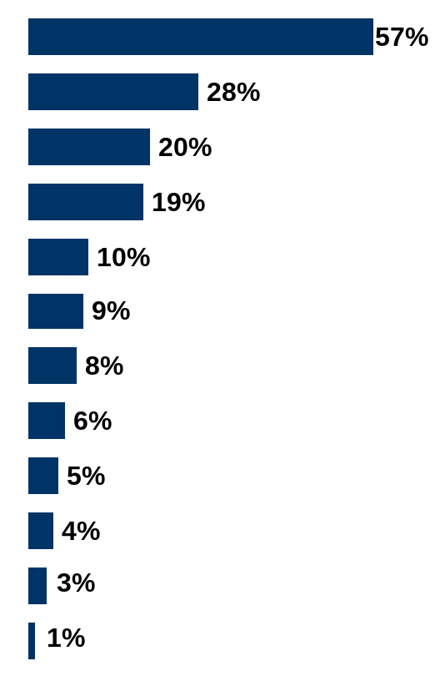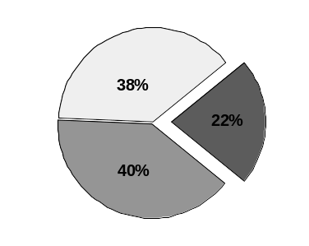
Awareness of Scouting Information
(From National BSA Research Service)
Television
Billboards
Boy Scouts of America Internet sites
Signs placed on lawns or yards
Question: From which of the following sources did you see or hear advertising, or receive other informational materials, about the Cub Scouts or Boy Scouts?
The radio
Newspapers
From a church or church group
At an event sponsored by the Boy Scouts of America
From a friend or family member
A flyer from a public school
Print ads in magazines
Base: Have heard advertising or received information about Scouts (n=794)
Aided responses. Multiple responses allowed. Not sure responses omitted.
Direct mailing
Have received information from Boy Scouts
Have received information from youth groups, not Boy Scouts
Have not received information from any youth groups
Appendix E-2:
(Sample)
Outcomes Survey/Evaluation

Percent of parents who agree with each statement:
 | Overall  Mean | Current  Boy Scout | Former  Boy Scout | Never a Boy Scout
Scouts learn  valuable skills | 4.38 | 96.2% | 82.1% | 77.0%
Scouting helps develop leadership traits | 4.31 | 93.9% | 81.5% | 73.2%
Scouts do fun  and exciting things | 4.28 | 93.0% | 80.7% | 74.7%
Scouting teaches young men respect for others | 4.21 | 92.6% | 80.8% | 70.3%
Scouting teaches strong morals and good values | 4.17 | 91.7% | 77.3% | 66.5%
Scouting builds self-esteem in young men | 4.11 | 93.9% | 74.6% | 63.3%
Scouting teaches young men to love their country | 4.06 | 90.7% | 70.8% | 62.7%
Scouting helps bring parents and sons together | 4.02 | 90.2% | 69.7% | 60.0%
The Boy Scouts wants families like mine to join | 3.97 | 91.6% | 66.3% | 56.9%
Scouts believe in God | 3.93 | 84.6% | 69.8% | 54.3%
My family’s values  and those of the  Boy Scouts are similar | 3.90 | 87.9% | 70.4% | 54.4%

Appendix E-2 continued:
(Samples)
Outcomes Survey/Evaluation

BASE = 1,001 parents of 11- to 13-year-old boys
SCALE: 5=Agree Strongly, 4=Agree Somewhat, 3=Neutral, 2=Disagree Somewhat, 1=Disagree Strongly
% based on those who strongly to somewhat agree with the statement

More than seven of 10 parents of non-Scouts agree “strongly” to “somewhat” that “Scouts learn valuable skills” (77.0%), “Scouts do fun and exciting things” (74.7%), “Scouting helps develop leadership traits” (73.2%), and “Scouting teaches young men respect for others” (70.3%).

Appendix F: (Sample) Letter of Inquiry/Cover
GRANT PROPOSAL EXAMPLE

(COVER LETTER)

Month, Date, Year
Jane Doe, Program Manager
Thebest Foundation
12345 6th Avenue
Any Town, Any State, Any Zip

Dear Ms. Doe,

The Eckswyzhee Council, Boy Scouts of America, respectfully requests a $39,530 grant from Thebest Foundation
to support the council’s Soccer and Scouting program. Specifically, this grant will enable 500 predominately
Hispanic/Latino American youth to join Cub Scout packs located in hard-to-serve neighborhoods, and will provide
for their membership fees, uniforms, and program supplies. We have leveraged funds from our United Way totaling
$36,000, which will support our program director’s salary.

Over the past five years, the council has demonstrated a sincere commitment in reaching out to more young Latinos
in Scouting. Fueled with the vision and dedicated volunteer leadership of our Scoutreach committee, many young
lives have been touched. Our focus now is to take this important program to the next exciting level for well into the
21st century.

On behalf of 55,555 young people served by Scouting’s guiding principles in our community, we wish to thank you
and the board of directors of the Thebest Foundation for your consideration of our request.

Sincerely,

John Roe
Endowment Director
Eckswyzhee Council

Appendix G: (Sample) Executive Summary
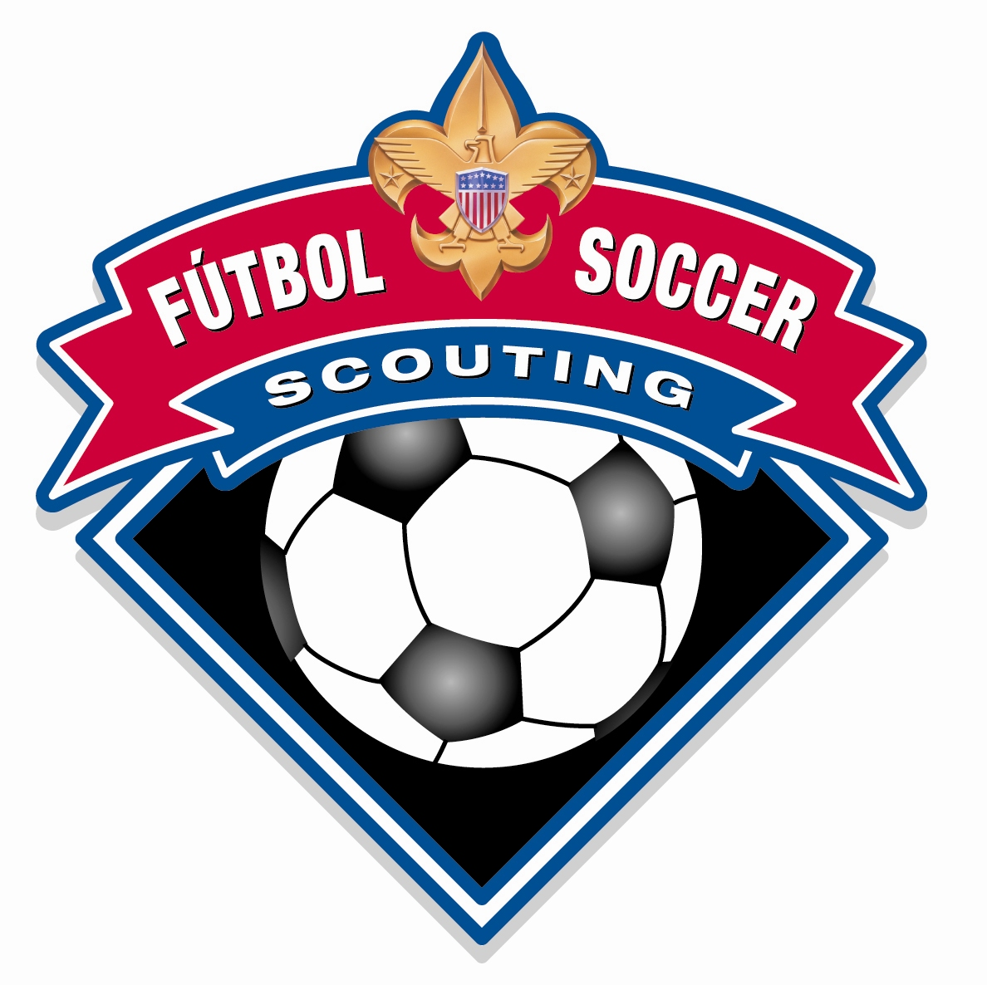 EXECUTIVE SUMMARY
“Soccer and Scouting”

Recent data from the U.S. Census Bureau has stated that Hispanic/Latino Americans are the largest minority group in the nation, representing 39.9 million people or 13 percent of the U.S population.

More than a decade ago, the Orange County Council, BSA headquartered in Santa Ana, California, realized that a non-traditional approach was needed to reach out to its booming Latino population. With guidance from Hispanic staff and community leaders, their plan of integrating soccer with traditional Scouting programs proved very successful. This program, which has been in action for 12 years, inspired the National Council to seriously consider implementing a new program that integrated elements of soccer with traditional Scouting values.

In March 2004, the Denver Area Council was selected to be the test pilot council for the new soccer program. The result of the test pilot was the formation of the new national Cub Scout program called Soccer and Scouting. And more important, the opportunity to serve more underserved youth and families through the popularity of soccer could no longer be overlooked.

Each season begins with a recruiting/organization day (interest generator day), followed by 10 weeks of den and game-day activities, and concludes with a tournament and graduation/recognition program. Another benefit, Latino youth can join Soccer and Scouting programs within walking distance of their homes. Cub Scout life skills programs are fully integrated into Soccer and Scouting. During the four 12-week seasons boys will work on their life skills program and earn immediate recognition as well as advance their personal soccer skills.

The outcomes we expect to accomplish as a direct benefit to youth are:

- Enhanced self-esteem and personal discipline
- The capacity to learn new skills and build new strengths
- Respect for themselves and each other
- A sense of pride in their rich ethnic heritage

Soccer and Scouting brings together the fastest growing youth sport in the United States and the world’s premier character building organization for boys and young adults. Soccer and Scouting program literature are provided both in English and Spanish to accommodate this growing audience. By working with other collaborative community organizations through specific marketing of this values-based sports program, enthusiastic and available Latinos and their families will want to join while they learn together important life skills needed to become participating adults in their communities.

The _____________ Council, Boy Scouts of America respectfully requests a grant from the (Foundation) for $___________. This grant will provide membership fees, uniforms, and program supplies. Thank you for your consideration of our request.

Appendix H: (Sample) Budget

A Sample Proposed Budget

Annual Budget – $ Requested from Year Year Year
Program Expansion [name] Foundation One Two Three

Program Supply Costs
Handbooks @ [amount] each [amount]
Registration @ [amount] each [amount]
Camping Cost [number] youth [amount]
Transportation [amount]
Awards/Recognition [amount]
Accident Insurance [amount]
Unit Equipment/Supplies [amount]

Subtotal [amount]

Personnel
Salary, Program Coordinator [amount]
- Paraprofessional, hourly [amount]
Office/Secretarial Support [amount]
Payroll Taxes [amount]

Subtotal [amount]

Nonpersonnel Cost
Supplies/Training [amount]
Travel [amount]
Postage [amount]

Subtotal [amount]

Total Cost [amount]

