NEW! Whitewater Rafting BSA Award
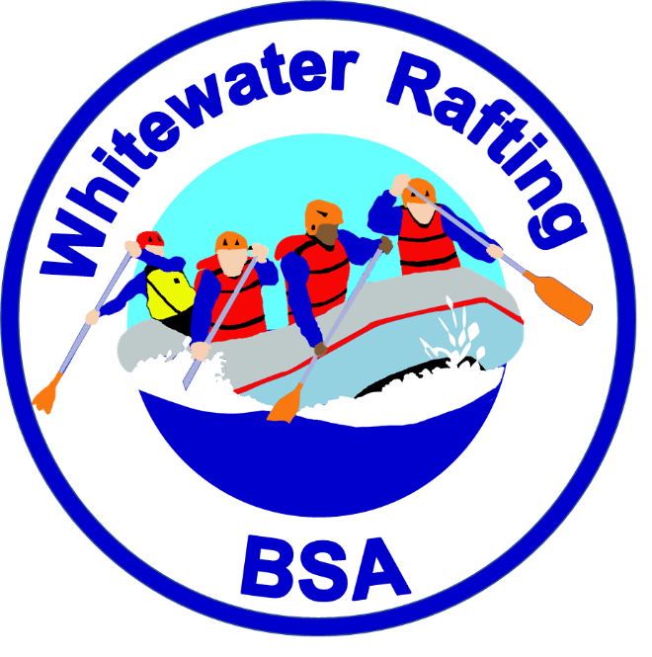
Many Scouting Units participate in rafting trips conducted by BSA National, Council and private outfitters. A new aquatics award, Whitewater Rafting BSA, recognizes the challenge and adventure of such activities. The award is available to BSA youth and adult members of Boy Scout, Varsity, Venturing or Sea Scout units.
The Requirements for the award focus on safety and basic paddling skills on whitewater up to Class III. All instruction and skill completions are directly supervised by a professionally trained or licensed rafting guide. A qualified raft captain must be in the raft during the trip. Participants help power and control the raft with paddles – simply riding in a raft rowed by a guide is not sufficient.
This new award will be featured at the 2017 National Jamboree
An application with requirements and notes to counselors will be placed on the aquatics page of Scouting.org http://www.scouting.org/scoutsource/OutdoorProgram/Aquatics.aspx
Patches and pocket cards are in production and will be available at www.scoutstuff.org and in local Scout Shops later this season. A support brochure is also planned.

Nationally Approved Historic Trails List Updated

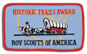

The National Camping Task Force recently released a new Nationally Approved list of recognized Historic Trails. The list had become dated and confused due to council mergers and lack of attention to the trail renewal process. The list contains confirmed trails and their host councils. However, we believe there are more trails that should be on this list but we have been unable to confirm the condition of the trails or if a council wants to continue to host a trail.
The Nationally Approved list of Historic Trails can be found here
http://bsatap.org/bsa-historic-trails-index/
Councils with trails which are believed to have been previously approved but are not on the list can submitted a renewal application found here http://www.scouting.org/filestore/Outdoor%20Program/pdf/430-933(15)_WEB.pdf
For new trails to be considered for inclusion on the Nationally Approved list here are the requirements and application http://www.scouting.org/filestore/Outdoor%20Program/pdf/430-240(15)_WEB.pdf

