Commissioner Tools FAQ

Please check the commissioner’s website regularly for the most up-to-date information.

GENERAL:
Q: Who will have access to what, and how is that determined?
A: Your access will be governed by the “natural context” of the “highest level” commissioner type for which you are registered. Unit-serving professionals will also have access. They will be able to create contacts; however, these contacts will not count toward JTE scoring, which as confirmed with the JTE leadership team, “would defeat the purpose of building a volunteer commissioner corps if it were to count toward JTE.” Council 2015 JTE item 14 and District 2015 JTE items 13 require the contacts be generated by registered commissioners.
Q: What are the browser requirements for this tool?
A: The tool is best experienced using the latest version of Google Chrome, or Mozilla Firefox. Also works with the latest version of Safari and Internet Explorer (v11). Older versions of IE are no longer supported.
Q: Will Commissioner Tools be mobi friendly?
A: An upgrade was implemented that now allows my.Scouting Tools to function correctly on iPads. The tools work best using Chrome. For Safari, you may need to change the settings and turn off popup blocker for the tools to work effectively.
Q: Will I be able to determine my council JTE score with Commissioner Tools?
A: No. Commissioner Tools is a robust program that was designed specifically to complement JTE but not replace it. For now, the council JTE score won’t be calculated by Commissioner Tools, but we will continue to improve the program and evaluate the feasibility of including the calculation in future releases.
UVTS HISTORY:
Q: For JTE purposes (2015 council item 14 and 2015 district JTE items 13), will the system count commissioner UVTS visits and the commissioner-logged Unit Contacts in Commissioner Tools?
A: Yes, UVTS data was uploaded to JTE at the time your council switched to Commissioner Tools and commissioner-logged contacts will continue to feed JTE.
Q: How do I access old UVTS data?
A: UVTS has been deactivated for all councils. Archived UVTS information is available in Commissioner Tools using the Archive button on each unit’s landing page. Additionally, your council was provided an electronic file with historical UVTS contacts information.
UNIT ASSESSMENTS:
Q: What is the purpose of the Detailed Unit Assessment?
A: The Detailed Unit Assessment is a collaborative effort by the unit Key 3 and Commissioner to form the basis of a Unit Service Plan. Usually completed only twice each year, a Detailed Unit Assessment includes:

- Collaborative goals that respond to unit needs;
- Resources from within the unit, its charter organization, and the district operating committee; and
- Accountability and target dates for fulfilling those goals.

Through ongoing unit contacts (simple assessments), commissioners capture periodic updates of the collaborative assessment of unit health and ensure the plan for improvement is moving forward. Although JTE is fundamental to Commissioner Tools’ design, JTE terminology or metrics are intentionally NOT used in the Commissioner Tools. This enables commissioners to help units implement a continuous improvement process irrespective of the formal JTE process and record keeping. Once users become familiar with Commissioner Tools, they will find the tool is fully supportive of JTE.
Q: What is the Unit Service Plan?
A: Like Journey to Excellence (JTE), the Unit Service Plan is a key element of the design of Commissioner Tools and is a better way to provide unit service. It supports all four elements of excellent unit service:

- Supporting unit growth through the Journey to Excellence;
- Contacting units and capturing their strengths and needs in Commissioner Tools;
- Linking unit needs to district operating committee resources;
- Supporting timely charter renewal and our approach to starting and sustaining high-performing units (detailed in the Unit Performance Guide).

Based upon a collaborative assessment of unit health, commissioners develop a service plan that is customized to respond to a unit’s strengths and needs and draws upon resources available within the unit, its charter partner, and through the district operating committee.

Through ongoing unit contacts, commissioners capture periodic updates of the collaborative assessment of unit health and ensure the plan for improvement is moving forward. Unit Service Plan information is located here.
Q: When should a simple or detailed contact assessment be used?
A: A simple contact assessment (a commissioner’s update of the Unit Service Plan) can be used when there is routine contact or an update to a specific item of interest. Detailed contact assessments are recommended a minimum of every 6 months, whenever there is a change in the unit Key 3, or the situation warrants.

Q: How do I send a Detailed Unit Assessment and who does it go to?
A: You must select a future date to send a Detailed Unit Assessment. An option appears to select and send the detailed Unit Assessment to the Unit Key 3. You can also add one additional “copy to” email address. The commissioner sending the assessment will be blind-copied.
Q: What if I don’t have a computer or Internet is not available?
A: Preprint a blank Commissioner Detailed Assessment form and fill it out manually to whatever extent desired. When complete, have a commissioner with Internet access transcribe the information into Commissioner Tools on your behalf.
Q: How long does a unit have to complete a detailed Unit Assessment?
A: A unit has 6 months, but it is of most benefit to the unit if done in a much shorter timeframe so the information is as timely as possible.
Q: Do you HAVE to fill out all the questions for a detailed contact?
A: No. You can put a manual score in the top section in one or more of the four categories – Finance, Membership, Program, Leadership and Governance – or answer all the individual questions in the category, as you desire. The most value is gained when completing all the questions in the entire detailed assessment.
Q: What does the 1 to 5 scale mean?
A: The 1 to 5 scale is a simple method to determine the condition of the area being assessed, 1 being low, 5 being high. The table below should help in the explanation (this matrix is the 2015 JTE version.)
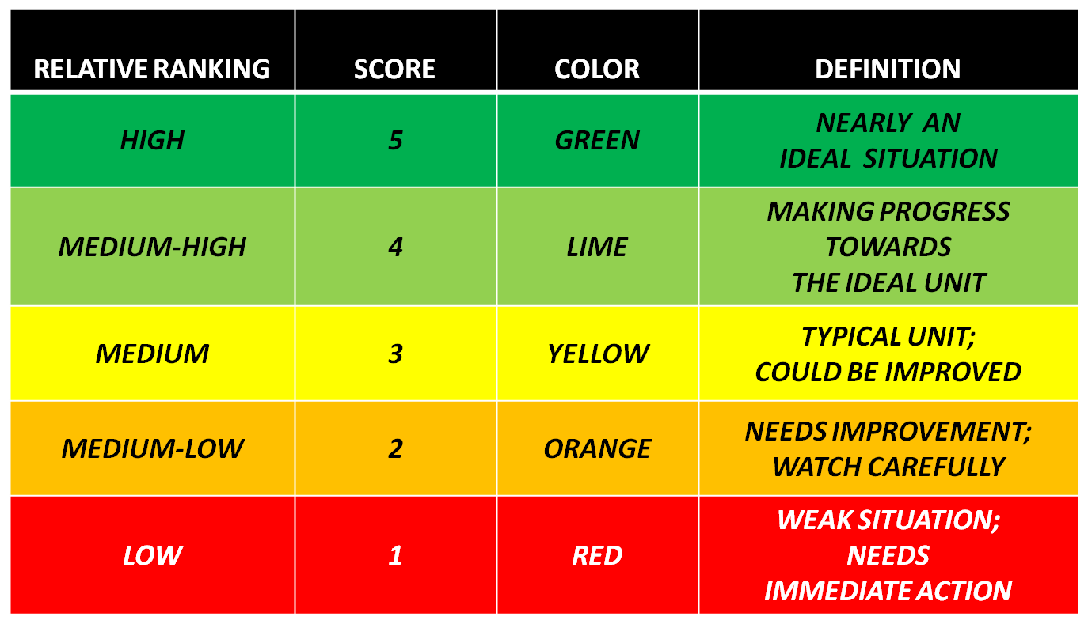

Q: Once an assessment is completed, how long do I have to make edits to the assessment?
A: Once completed – you have 48 hours to make edits.
Q: Can I delete a completed Assessment?
A: No. Once an Assessment is in a completed status, it cannot be deleted.
DASHBOARDS:
Q: Who will have access to training and membership records of the units?
A: This information will be available to each Unit Key 3 thru My.Scouting.org and all registered commissioners as well as unit-serving professionals when Commissioner Tools are adopted by your council.
Q: Will commissioners be able to access training records for specific individuals?
A: Yes, but not through Commissioner Tools. On the home screen of My.Scouting.org the pull down menu has a Training Manager option that will allow access to training records.
Q: Why does my unit dashboard not display the bar graph for the four JTE categories: Finance, Membership, Program, Leadership and Governance?
A: The dashboard reflects the most recent contact assessment recorded. If the last contact assessment completed for a unit was a simple contact assessment then these four detailed totals are not available.
Q: Can the unit commissioner see rechartering or advancement information?
A: These will both be available when future My.Scouting tools are developed and released.
UNIT CONTACTS:
Q: Who will assign the units?
A: Initially all units will be unassigned. Administrative commissioners will assign Unit Commissioners to their appropriate units. Unit Commissioners will also be assigned to an Assistant District Commissioner.
Q: What units will I see if I am a unit commissioner?
A: On your Commissioner Profile, you will see only those units that have been assigned by your administrative commissioner. In the Commissioner Tools system though you will see and have access to all the units in the district where you are registered.
Q: Can I make a Unit Contact entry for any unit in my council?
A: Yes. You may search for other units within your council and enter contacts for other commissioners or as a visiting commissioner yourself.
Q: How long do I have to make an entry after contact?
A: You will have 60 days from the date of your contact to enter information.
ROUNDTABLES:
Q: Can Roundtable Commissioners and Ass’t RTCs make Unit Contact reports?
A: Yes. RTCs and assistant RTCs are commissioners and encouraged to make entries when appropriate.
Q: Can Roundtable Commissioners send Roundtable messages to unit points of contact?
A: All commissioners can access units to make contacts. In the future, there will be the ability within the My.Scouting.org Tools to generate targeted communications – it will not be restricted to Commissioner Tools exclusively.
Q: Can documents be uploaded and attached for Roundtable Contact entries?
A: Not in Release 1, however you may copy the content of your text documents and save it into the meeting notes.
Q: Can multiple units be given Roundtable attendance “credit” for the same individual?
A: Yes, if you desire. You can either give each of the units “whole” credit, or “half” credit as is the custom of your Roundtable.
Q: Why do I have to enter a total for unit leaders in each program and also enter in the individual unit attendance totals?
A: The tools allow for tracking attendance for each unit separately because some unit leaders may attend representing multiple units, or he/she could represent a unit leader and a commissioner. For example the leader could be gathering materials for two packs and a troop. How this person is counted is left up to the council and the commissioners for that organization structure. The unit totals allow for decimal numbers so a person may be counted as a 0.5 for one unit and a 0.5 for a second unit. Thus the overall attendance headcount may not equal the separate unit totals.
Q: What if my council/district has separate roundtables by program?
A: The tools are built so that you can record these separately if you like however you can only enter one per “Facilitator” per Roundtable Contact If it’s important to document different Facilitators for each program area, then the approach to take is to make separate Roundtable Contact entries for each program area. The point to note is that only one roundtable is highlighted in the dashboard – so the most recent roundtable entered will be displayed in the dashboard.
Q: Why does my Roundtable dashboard only display a few programs?
A: The dashboard reflects the last roundtable recorded in the organization structure. So, if only limited programs were in attendance those programs will be listed in the dashboard header.
Q: How long do I have to edit an entry if I forgot something?
A: Once completed – you have 48 hours for Unit Contacts, 60 days for Roundtable Contacts to make edits. You may also add information in a comment area at any time.
Q: Can I delete a completed Roundtable?
A: No, once a Roundtable is in a completed status, it cannot be deleted. However, you can delete any Roundtable still in Progress but not completed or scheduled.
REPORTS:
Q. What reports are available?
A: In Release 1 there are over 11 different reports and a variety of dashboards available; more will be added in future releases. Reports included in Release 1 are as follows:

District Contact Stats 2015
District Contact Stats 2014
Assigned Units
Assigned Expired Units
Unassigned Expired Units
Expired Units
Commissioner Activity
Unit Health
Commissioner Recruitment
Commissioner Contact Stats
Priority Needs Units
Unassigned Units Commissioner Recruitment
Youth Protection Training Aging Report
Trained Leaders Report
Unit Rosters (Calling List, Member List, and Mailing List)
Youth Member Age Report

RESOURCES:
Webpage where all documents are found including Unit Service Plan PowerPoint, training videos, weekly updates on Commissioner Tools functionality, and the blank assessment documents:
http://www.scouting.org/scoutsource/Commissioners/tools.aspx

