
By giving to the [COUNCIL NAME]’s Scouting for Food drive, you are helping those in need right here in the [REGION NAME] community. Last year, we collected [# of ITEMS and/or POUNDS OF FOOD] that Scouts distributed to [#] shelters across [#] counties.
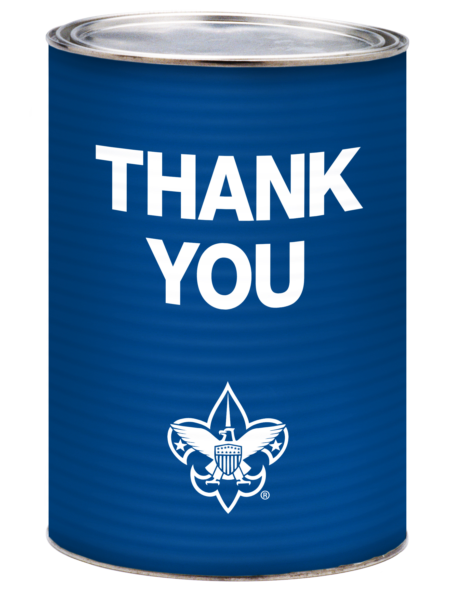
Scouting for Food is just one way the Boy Scouts of America works to improve communities across the nation. Scouts are active cleaning up parks, building houses, gathering for the needy, and even helping with disaster preparedness. We need millions of volunteers to provide these opportunities for youth to learn and grow. Call XXX-XXX-XXXX or visit [URL] to find out how you can help support the [COUNCIL NAME]. Even just a few hours of your time will make a difference.
If you were a Scout, family member of a Scout, BSA volunteer, or just someone who Scouting has positively impacted, we invite you to join. Visit www.BSAalumni.org to learn how!
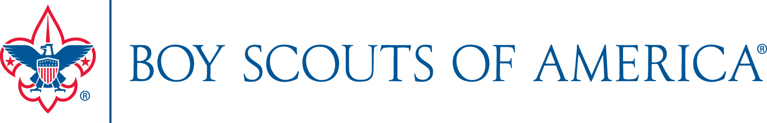
By giving to the [COUNCIL NAME]’s Scouting for Food drive, you are helping those in need right here in the [REGION NAME] community. Last year, we collected [# of ITEMS and/or POUNDS OF FOOD] that Scouts distributed to [#] shelters across [#] counties.
Scouting for Food is just one way the Boy Scouts of America works to improve communities across the nation. Scouts are active cleaning up parks, building houses, gathering for the needy, and even helping with disaster preparedness. We need millions of volunteers to provide these opportunities for youth to learn and grow. Call XXX-XXX-XXXX or visit [URL] to find out how you can help support the [COUNCIL NAME]. Even just a few hours of your time will make a difference.
If you were a Scout, family member of a Scout, BSA volunteer, or just someone who Scouting has positively impacted, we invite you to join. Visit www.BSAalumni.org to learn how!

